R-20
Web Technologies Lab Manual
III B. Tech I Semester

WEB TECHNOLOGIES LAB

B. Tech III Year I Semester |  |  |  |  | Dept. of Information Technology
Code | Category | Hours / Week |  |  | Credits | Marks
 | Core | L | T | P | C | CIE | SEE | Total
 | Core | 0 | 0 | 3 | 1.5 | 50 | 50 | 100

Course Outcomes
At the end of this Web Technologies lab course, students will be able to:
- Design static web pages and validate using javascript.
- Implement database connectivity using JDBC
- Create Database and Manipulate data using Open Source Tools
- Deploy servlet-servlet chaining
- Construct Dynamic web pages using Servlets and JSP

Week 1
Practice Basic HTML Programs:
- Basic Tags
- Lists
- Tables
- Frames
- Forms
- Div and Span

Week 2
Design the following static web pages required for online book store application.
- Registration page
- Login page
- User profile page
- Shopping page
- Catalog page
Apply internal and external CSS (Cascading Style Sheets) for Online book store application.

Week 3
Implement Alert Box, Confirm Box, Prompt Box. & Control Structures, Conditional Statements using Javascript.

Week 4
Write JavaScript to validate the following fields of registration page[Book Store Application]: Username Field, Password Field, Phone Number Field, Email-id.

Week 5-6
Introduction to Open Source database tools - MySql / Mongo DB/ No SQL.
Perform Data Definition Language (DDL) and Data Manipulation Language (DML) commands using open source tools.
Implement Database connectivity using JDBC and perform the following:
i) Table creation ii) Data Manipulation.

Week 7
Apache Tomcat Installation Procedure.
Write a program to display the HELLO WORLD message using Java servlet.

Week 8-9
Develop a Java Servlet application to implement and demonstrate get() and post() methods (Using HTTPServlet Class)
Write a Java Servlet program to implement a dynamic HTML using servlet (Username and password should be accepted using HTML and displayed using Servlet)
Write a JAVA Servlet to track HttpSession by accepting user name and password using HTML and display the profile page on successful login.

Week 10
Write a Java Servlet application using Cookies to remember user preferences.
Write a Java Servlet to Auto web page refresh (consider a webpage which is displaying Date and time or stock market status. For all such type of pages, you would need to refresh your web page regularly; Java servlet makes this job easy by providing refresh automatically after a given interval.

Week 11
Demonstrate the Java servlet-servlet chaining.
Demonstrate the Java servlet and JDBC connection.

Week 12-13
Introduction to JSP.
Write a program to display the HELLO WORLD message using JSP.
Write a JSP program which uses jsp:include and jsp:forward action to display a Webpage.
Write a Java JSP program which uses <jsp:plugin> tag to run a applet.

Week 14-15
Write a JSPapplication to insert data into the STUDENT database and retrieve info based on particular queries (For example, update, delete, and others).
Write a Java JSP program to implement all attribute of page directive tag.

Week 16
Review.

Week 1
Practice Basic HTML Programs:
1. Basic Tags
2. Lists
3. Tables
4. Frames
5. Forms
6. Div and Span

Basic Tags Program:

<html>
<head>
<title>My first prog</title>
</head>
<body bgcolor="red">
<h1>anurag university</h1>
<h2>anurag university</h2>
<h3>anurag university</h3>
<h4>anurag university</h4>
<h5>anurag university</h5>
<h6>anurag university</h6>
<hr>
<b>this is the bold tag</b><br>
<i>this is italic tag</i><br>
<u>this is underline tag</u><br>
<p>this is a paragraph tag</p>
<tt>this is a tele type tag</tt><br>
<font color="green">this is colr tag</font><br>
H<sub>2</sub>O<br>
a<sup>2</sup>+b<sup>2</sup><br>
a&ltb<br>
a&gtb<br>
<marquee>this is scrolling tag</marquee><br>
<img src="G:\Certificates & Photo sign\Thanvika\Thanvika Passport photo.jpg"</img><br>
<a href="www.google.com">click me</a>
</body>
</html>

Output:

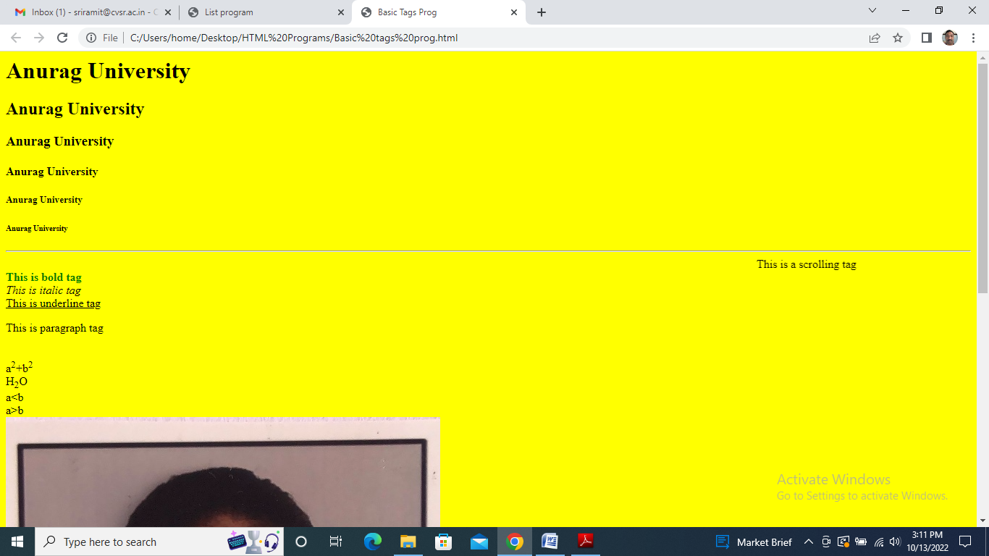

Lists Program:
<html>
<head>
<title>List program</title>
</head>
<body>
<ol type="a">Programming Languages:
<li>C</li>
<li>C++</li>
<li>Java</li>
</ol>
<ul>Markup languages:
<li>html</li>
<li>xml</li>
<li>php</li>
</ul>
<dl>
<dt>HTML:</dt>
<dd> HTML stands for Hyper Text Markup Language</dd>
</dl>
</body>
</html>

Output:

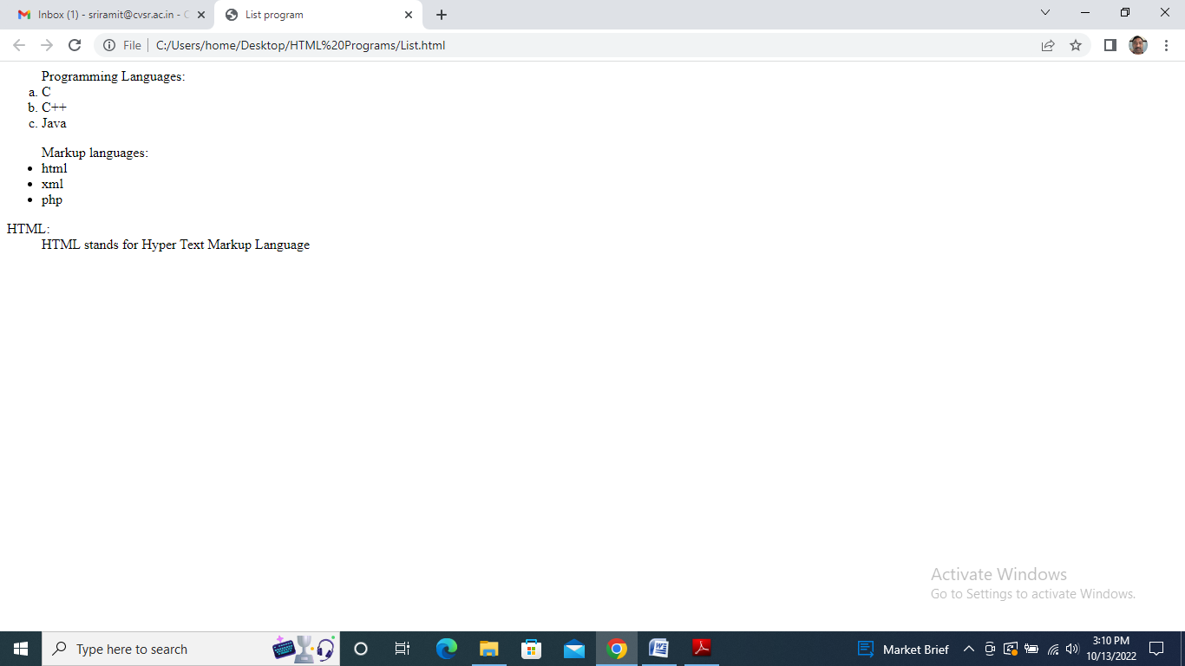

Tables Program:

<html>
<head>
<title>Table prog</title>
</head>
<body>
<table border="5">
<tr>
<th colspan="9"><font color="red"><marquee>IT-III-I-A Section Timetable</marquee></font></th>
</tr>
<tr>
<th>Day/time</th>
<th>9:00-9:55</th>
<th>9:55-10:50</th>
<th>10:50-11:45</th>
<th>11:45-12:40</th>
<th>12:40-1:20</th>
<th>1:20-2:15</th>
<th>2:15-3:10</th>
<th>3:10-4:05</th>
</tr>
<tr>
<th> Monday</th>
<td>OOAD</td>
<td>wt</td>
<td>DAA</td>
<td>os</td>
<td rowspan="2">LUNCH</td>
<td>AA</td>
<td>Counseling</td>
<td>Lib</td>
</tr>
<tr>
<th> Tuesday</th>
<td>OOAD</td>
<td colspan="3"><center><font color="green">wt Lab</font></center></td>
<td>AA</td>
<td>Counseling</td>
<td>Lib</td>
</tr>
</table>
</body>
</html>

Output:

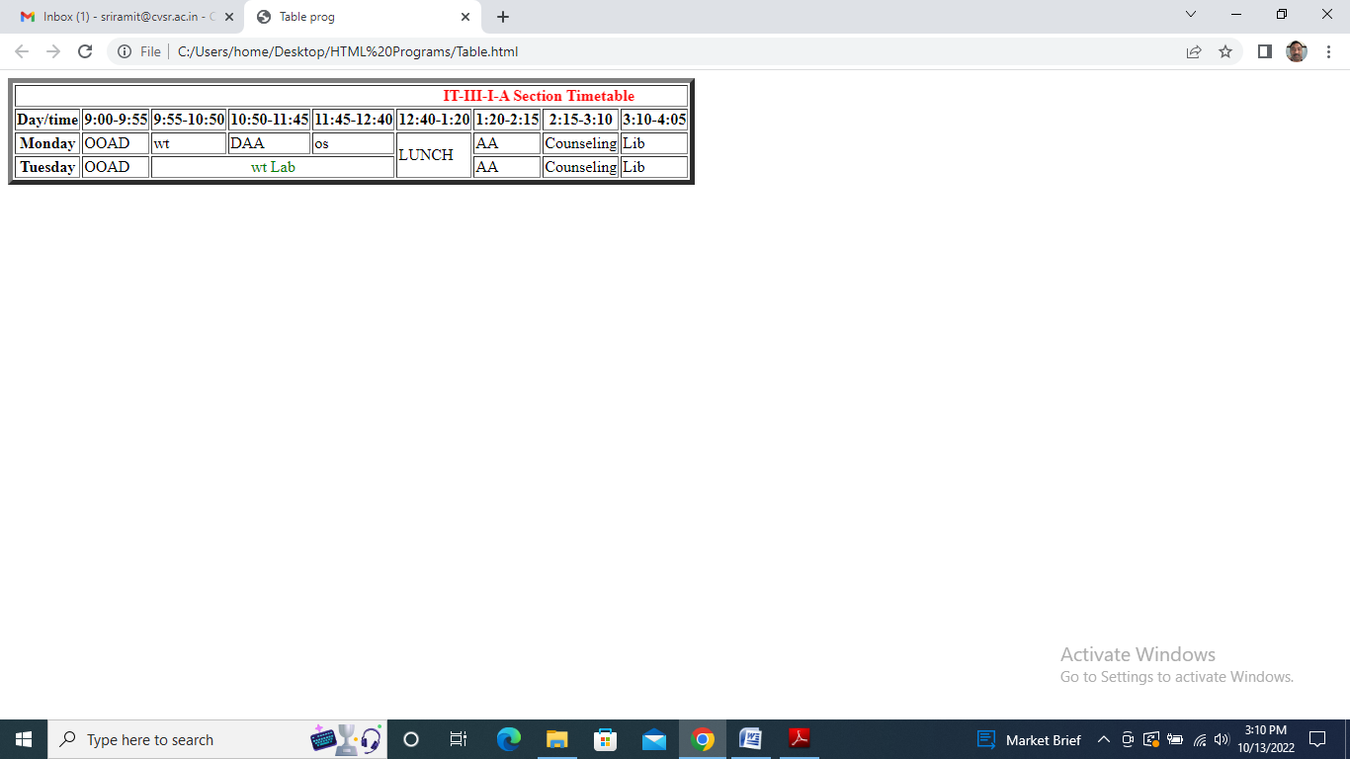

Frames Program:

<html>
<head>
<title>Frames prog</title>
</head>
<frameset rows="200, *">
<frame src="a.html" scrolling="no" name="a">
<frameset cols="400,*">
<frame src="b.html" scrolling="no" name="b">
<frame src="c.html" scrolling="no" name="c">
</frameset>
</frameset>
</html>

a.html:
<html>
<h1><marquee><font color="red">Anurag University</font><marquee></h1>
</html>
b.html:
<html>
<body>
<h1> The departments are:</h1>
<a href="IT.html" target="c">IT Department</a><br>
<a href="CSE.html" target="c">CSE Department</a><br>
<a href="ECE.html" target="c">ECE Department</a><br>
<a href="EEE.html" target="c">EEE Department</a><br>
</body>
</html>
IT.html:
<html>
<body>
<h1> IT department is established in 2007 with 60 students, now it is increased to 180</h1>
</body>
</html>

Output:

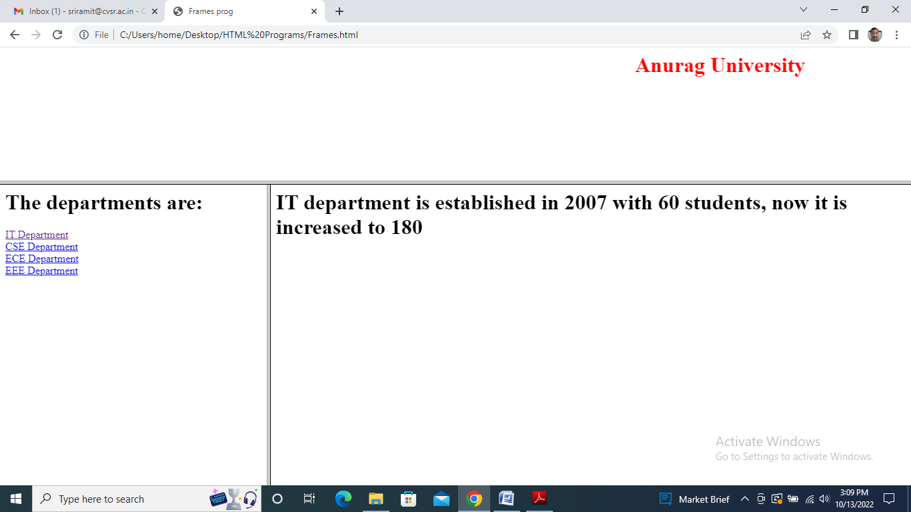

Forms Program:

<html>
<head>
<title>Forms prog</title>
</head>
<body>
Name:
<input type="textbox" name="t1" value=" " size="30"><br>
S/o: <input type="textbox" name="t2" value=" " size="30"><br>
Gender:
<input type="radio" name="r1" value="M">Male
<input type="radio" name="r1" value="F">FeMale<br>
DOB:
<select Option="Date">
<option value="1" selected>1
<option value="2" selected>2
<option value="3" selected>3
<option value="4" selected>4
</select>
<select Option="Month">
<option value="1" selected>1
<option value="2" selected>2
<option value="3" selected>3
<option value="4" selected>4
</select>
<select Option="Year">
<option value="2001" selected>2001
<option value="2002" selected>2002
<option value="2003" selected>2003
<option value="2004" selected>2004
</select><br>
Languages Known:
<input type="checkbox" name="c1" value=" ">Telugu
<input type="checkbox" name="c2" value=" ">Hindi
<input type="checkbox" name="c3" value=" ">English<br>
Address:
<textarea name="ta1" value=" " rows="20" cols="20"></textarea><br>
<input type="button" name="b1" value="submit">
<input type="button" name="b2" value="Reset"> <br>
</body>
</html>

Output:

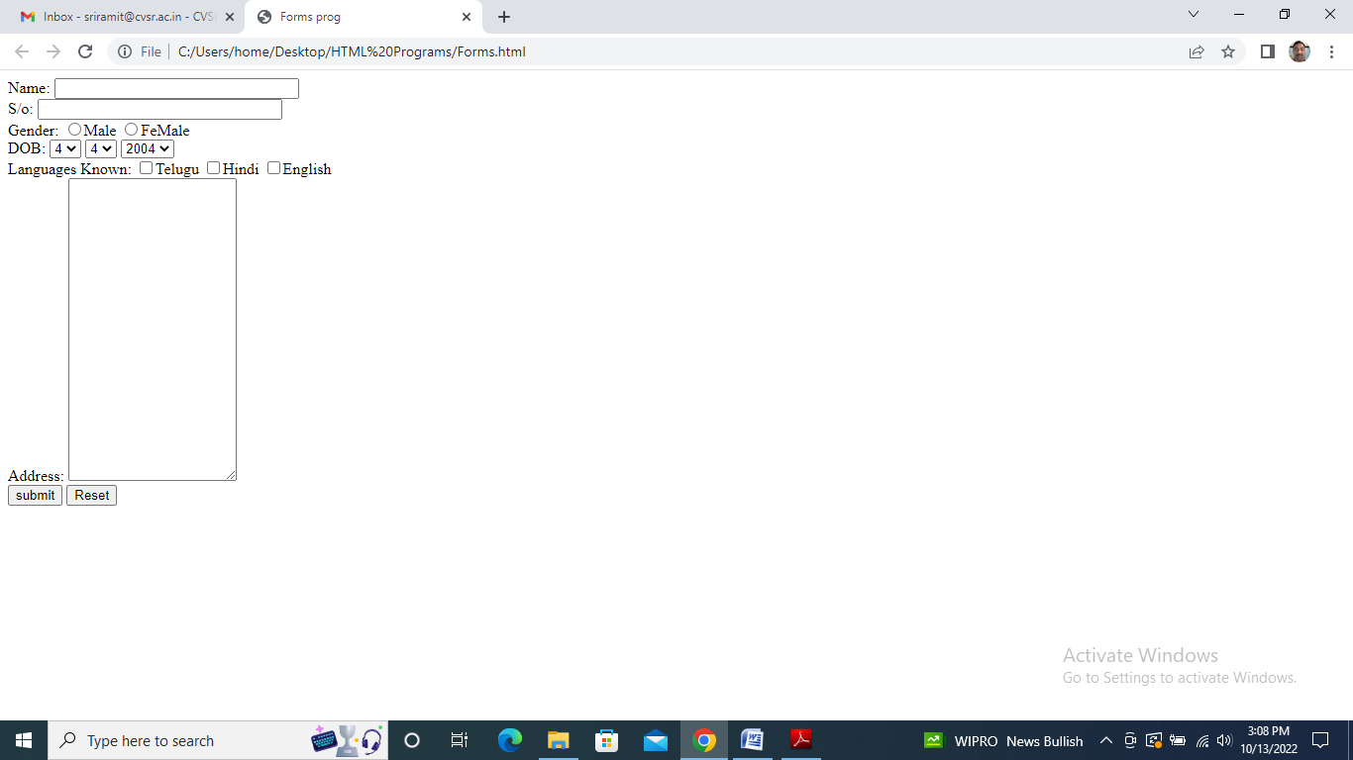

Span tag Program:

<html>
<body>
<p> my freind is having
<span style="color:blue">blue</span> eyes</p>
</body>
</html>

Output:

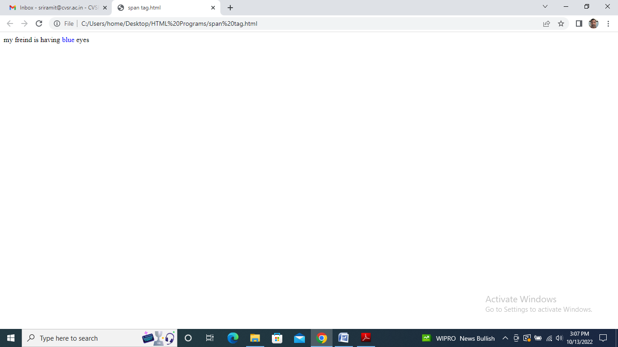

Div tag Program:

<html>
<body>
<div style="color:red">
<h1>hi</h1>
<h4>how r u</h4>
<h6>fine</h6>
<p>this is div tag portion</p>
</div>
<h2>III Year</h2>
</body>
</html>

Output:

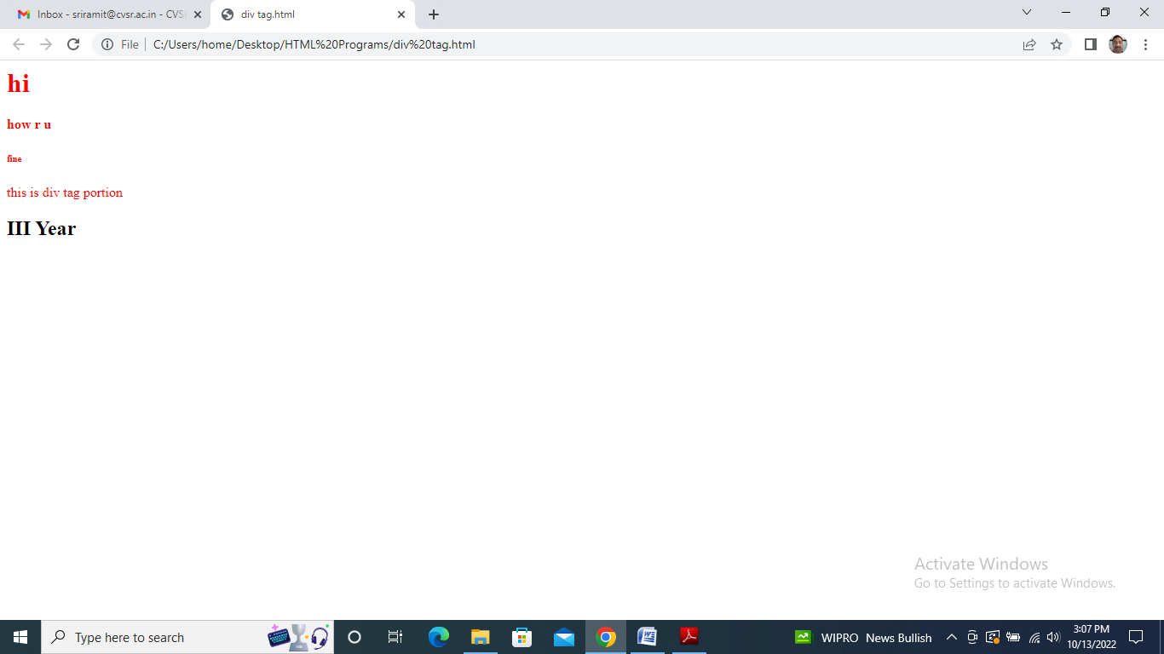

Week 2
Design the following static web pages required for online book store application.
1. Registration page
2. Login page
3. User profile page
4. Shopping page
5. Catalog page
Apply internal and external CSS (Cascading Style Sheets) for Online book store application.

<html>
<head><title>Online Book Store</title></head>
<frameset rows="27%,*%">
<frame noresize="noresize" src="frame1.html">
<frameset cols="19%,81%">
<frame noresize="noresize" src="frame2.html">
<frame noresize="noresize" src="frame3.html" name="showframe"> </frameset>
</frameset>
</html>
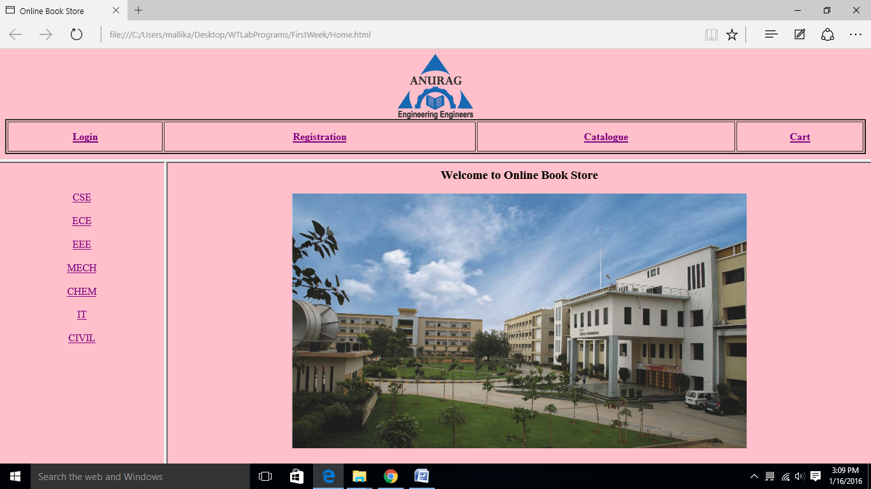
Registration.html
<html>
<head>
<title>REGISTRATION FORM</title>
</head>
<body bgcolor="pink">
<h2 align="center">ONLINE REGISTRATION</h2>
<hr align="center" width="100%" />
<table align="center" cellspacing="12">
<tr>
<td align="right">First name:<font color="red"><sup>*</sup></font></td>
<td align="left"><input type="text" maxlength="40" size="35" name="fname">
</tr>
<tr>
<td align="right">Last name:<font color="red"><sup>*</sup></font></td>
<td align="left"><input type="text" maxlength="40" size="35" name="lname">
</tr>
<tr>
<td align="right">PassWord:<font color="red"><sup>*</sup></font></td>
<td align="left"><input type="PassWord" maxlength="40" size="35" name="pw">
</tr>
<tr>
<td align="right">Confirm PassWord:<font color="red"><sup>*</sup></font></td>
<td align="left"><input type="PassWord" maxlength="40" size="35" name="cp">
</tr>
<tr>
<td align="right">Gender:</td>
<form>
<td><input type="radio" name="sex" value="male" /> Male
<input type="radio" name="sex" value="female" /> Female</td>
</form>
</tr>
<tr>
<td align="right">DATE OF BIRTH:</td>
<td align="left">
<select name="dob">
<option value="x">Month</option>
<option value="j">JAN</option>
<option value="f">FEB</option>
<option value="m">MAR</option>
<option value="A">APR</option>
<option value="m">MAY</option>
<option value="j">JUN</option>
<option value="j">JUL</option>
<option value="j">AUG</option>
<option value="v">SEP</option>
<option value="o">OCT</option>
<option value="n">NOV</option>
<option value="d">DEC</option>
</select>
<select name="dob1">
<option value="v">DAY</option>
<option value="1">01</option>
<option value="2">02</option>
<option value="3">03</option>
<option value="4">04</option>
<option value="5">05</option>
<option value="6">06</option>
<option value="7">07</option>
<option value="8">08</option>
<option value="9">09</option>
<option value="c">10</option>
<option value="x">11</option>
<option value="a">12</option>
<option value="q">13</option>
<option value="f">14</option>
<option value="o">15</option>
<option value="s">16</option>
<option value="y">17</option>
<option value="z">18</option>
<option value="i">19</option>
<option value="j">20</option>
<option value="h">21</option>
<option value="e">22</option>
<option value="u">23</option>
<option value="e">24</option>
<option value="c">25</option>
<option value="b">26</option>
<option value="v">27</option>
<option value="p">28</option>
<option value="o">29</option>
<option value="k">30</option>
<option value="c">31</option>
</select><select name="dob3">
<option value="ram">YEAR</option>
<option value="2010">2010</option>
<option value="2009">2009</option>
<option value="2008">2008</option>
<option value="2007">2007</option>
<option value="2006">2006</option>
<option value="2005">2005</option>
<option value="2004">2004</option>
<option value="2003">2003</option>
</select>
<tr>
<td align="right">Email-ID:<font color="red"><sup>*</sup></font></td>
<td align="left"><input type="text" maxlength="40" size="35" name="ename">
</tr>
<tr>
<td align="right">Phone number:<font color="red"><sup>*</sup></font></td>
<td align="left"><input type="text" maxlength="40" size="35" name="phn">
</tr>
<tr>
<td align="right">Languages known:</td>
<td align="left"><input type="checkbox" name="hb" value="en">English</td>
<td align="left"><input type="checkbox" name="hb" value="te">Telugu</td>
</tr>
<tr>
<td align="right">Address:<font color="red"><sup>*</sup></font></td>
<td align="left"><textarea rows="6" cols="20" name="add"> </textarea> </td>
</tr>
<tr>
<td></td>
<td align="left"><input type="checkbox" name="xx" value="yy">I Agree with terms and
Conditions</td>
</tr>
<tr> <td></td>
<td align="left"><input type="SUBMIT" value="SUBMIT"></td>
<td align="right"><input type="RESET" value="RESET"></td>
</tr>
</table></body>
</html>

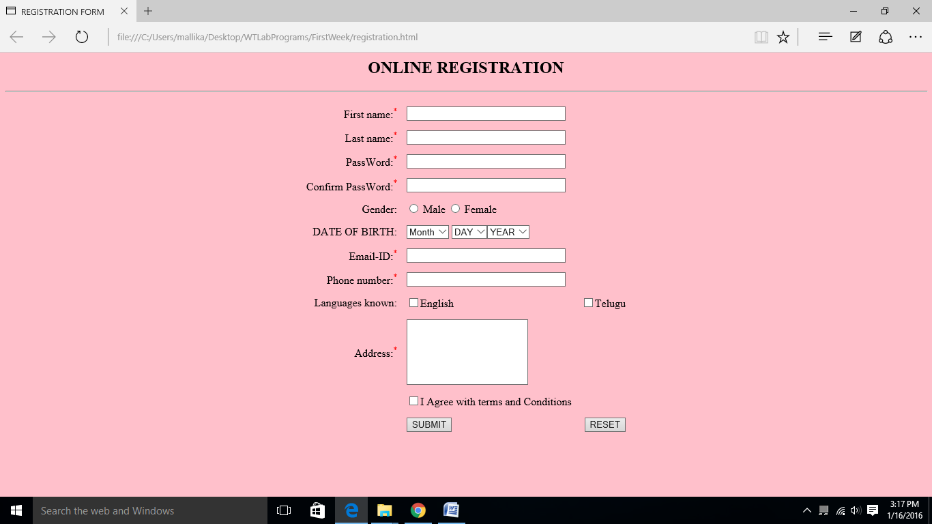
Login.html
<html>
<head><title>Login Page</title></head>
<body bgcolor="pink">
<form action="">
<center>
<pre>
<h2>Login Id:<input type="text" name="login"/><br>
Password:<input type="password" name="pwd"/><br>
<input type="submit" name="sub" value="Login"/>
<input type="button" name="rst" value="Reset"/></h2>
</pre></center>
</form></body>
</html>
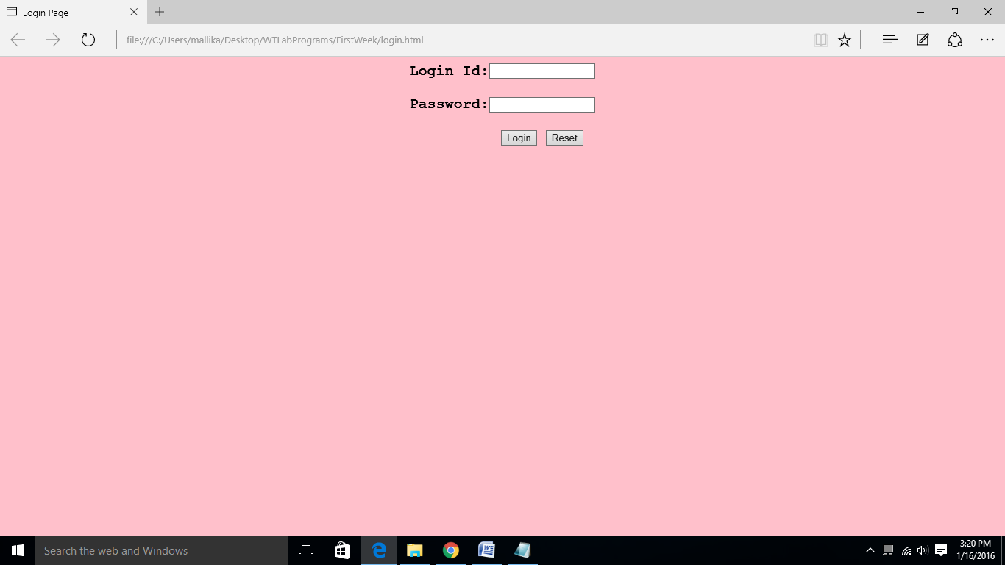
Frame1.html
<html>
<body bgcolor="pink">
<center><img src="logo.png" alt="AGI"></center>
<table border="2" bordercolor=black align="center" width="100%" height=55>
<tr>
<th><a href="login.html" target="showframe">Login</a></th>
<th><a href="registration.html" target="showframe">Registration</a></th>
<th><a href="catalogue.html" target="showframe">Catalogue</a></th>
<th><a href="cart.html" target="showframe">Cart</a></th>
</tr>
</table>
</html>

Week 3
Implement Alert Box, Confirm Box, Prompt Box. & Control Structures, Conditional Statements using Java script.

Alert Box Program:

<html>
<head>
<script type="text/javascript">
function disp_alert()
{
alert ("if you want to delete this file plz press ok button");
}
</script>
</head>
<body>
<input type="button" onclick="disp_alert()" value="Button">
</body>
</html>

Output:

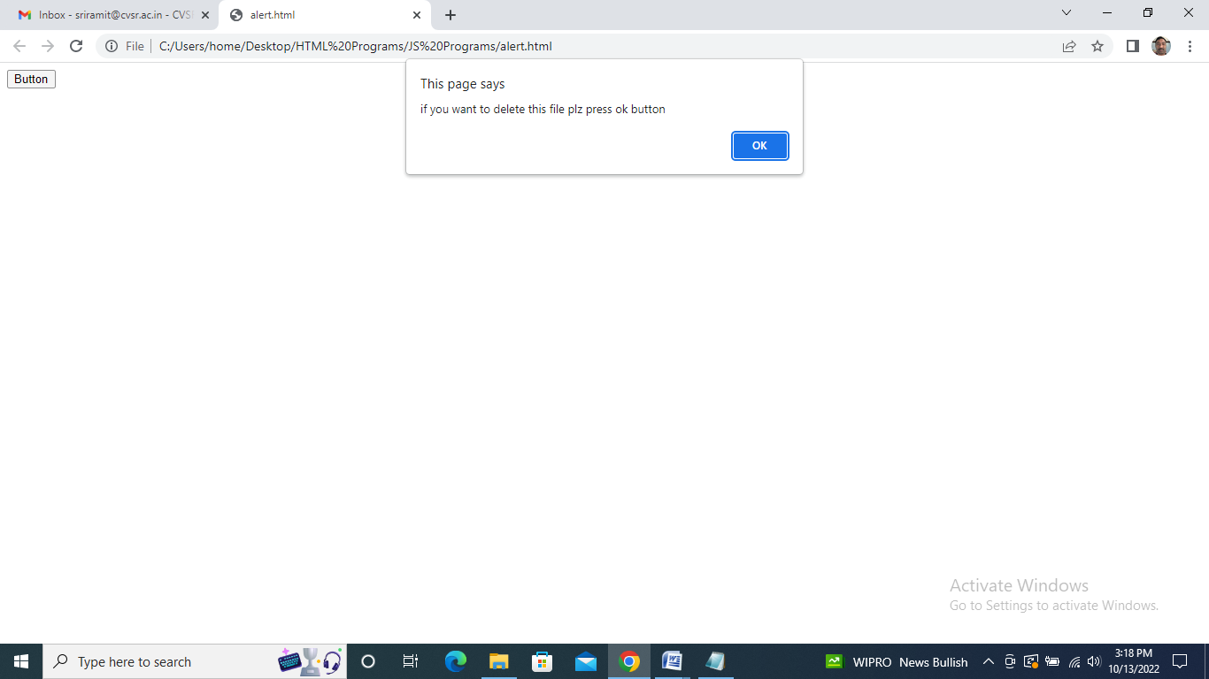

Confirm Box Program:

<html>
<head>
<script type="text/javascript">
function disp_confirm()
{
var r=confirm("press a button");
if(r==true)
{
document.writeln("he pressed ok button");
}
else
{
document.writeln("he pressed cancel button");
}
}
</script>
</head>
<body>
<input type="button" onclick="disp_confirm()" value="button" >
</body>
</html>

Output:

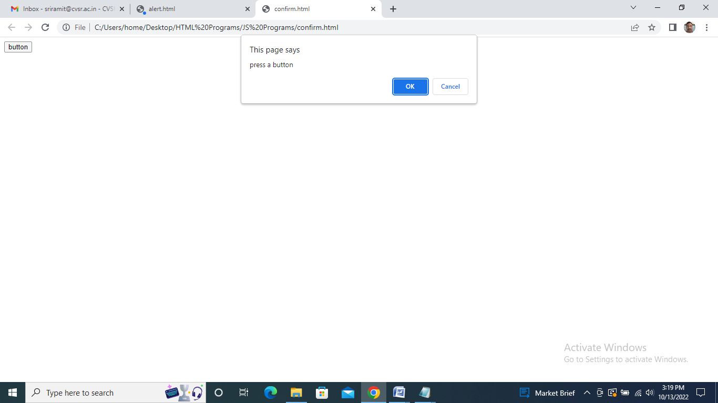

Prompt Box Program:

<html>
<head>
<script type="text/javascript">
function disp_prompt()
{
var name=prompt("please enter u r name", " ");
if(name!=null&&name!=" ")
{
document.writeln("Hello"+ name+ "!How r u");
}
}
</script>
</head>
<body>
<input type="button" onclick="disp_prompt()" value="button">
</body>
</html>

Output:

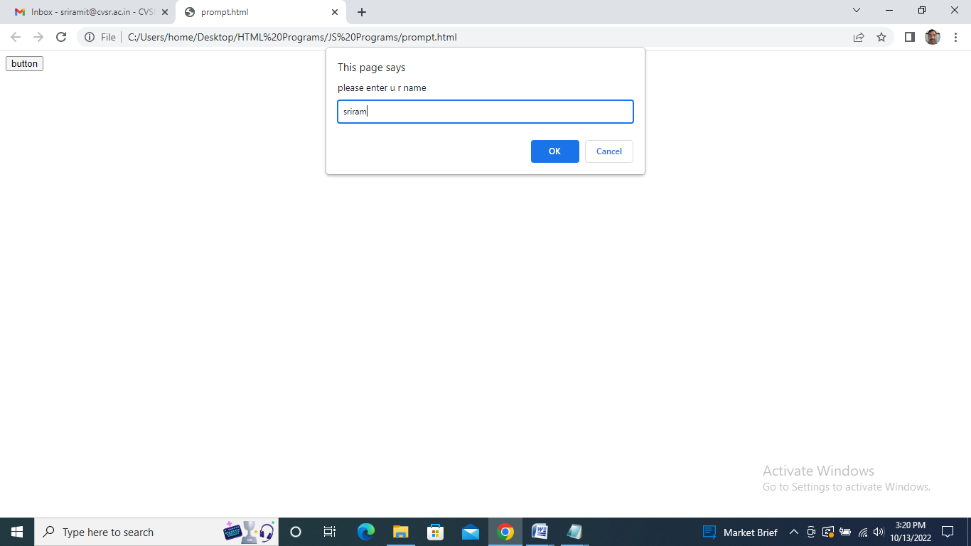

Conditional Statements Program:

<html>
<body>
<script type="text/javascript">
for(var i=0;i<=10;i++)
{
document.write(i);
}
</script>
</body>
</html>

Output:

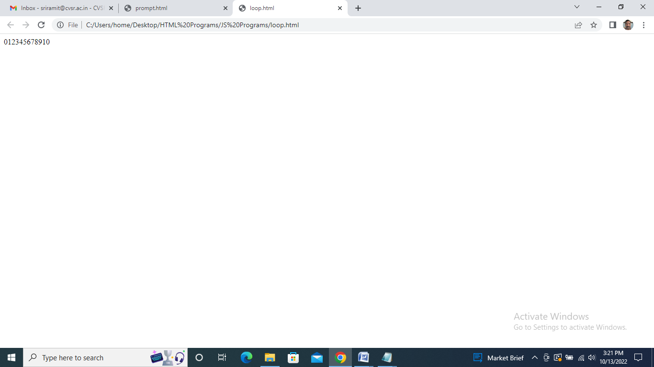

Week 4
Write JavaScript to validate the following fields of registration page [Book Store Application]: Username Field, Password Field, Phone Number Field, Email-id.

Name & Password Validation Program:

<!DOCTYPE html>
<html lang="en">
<head>
<meta charset="UTF-8">
<title>valide</title>
<script>
function validateform(){
var name=document.
myform.name.value;
var password=document.myform.password.value;
if (name==null || name==""){

alert("Name can't be blank");
return false;
}else if(password.length<6){
alert("Password must be at least 6 characters long.");
return false;
}
}
</script>
</head>
<body>
<form name="myform" method="post"
action="abc.jsp" onsubmit="return validateform()" >
Name: <input type="text" name="name"><br/>
Password: <input type="password" name="password"><br/>

<input type="submit" value="register">
</form>
</body>
</html>

Output:

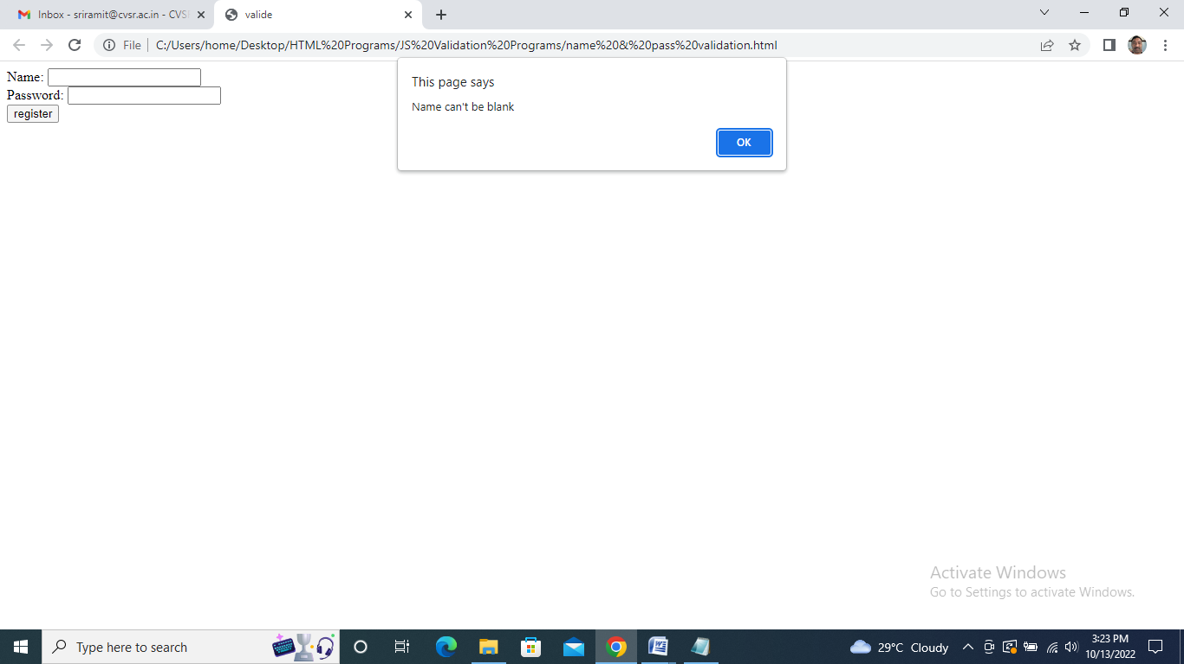

Confirm Password Validation Program:

<script type="text/javascript">
function matchpass(){
var firstpassword=document.f1.password.value;
var secondpassword=document.f1.password2.value;

if(firstpassword==secondpassword){
return true;
}
else{
alert("password must be same!");
return false;
}
}
</script>

<form name="f1" action="register.jsp"
onsubmit="return matchpass()">
Password:<input type="text" name="password" /><br/>
Re-enter Password:<input type="text"
name="password2"/><br/>

<input type="submit">
</form>

Output:

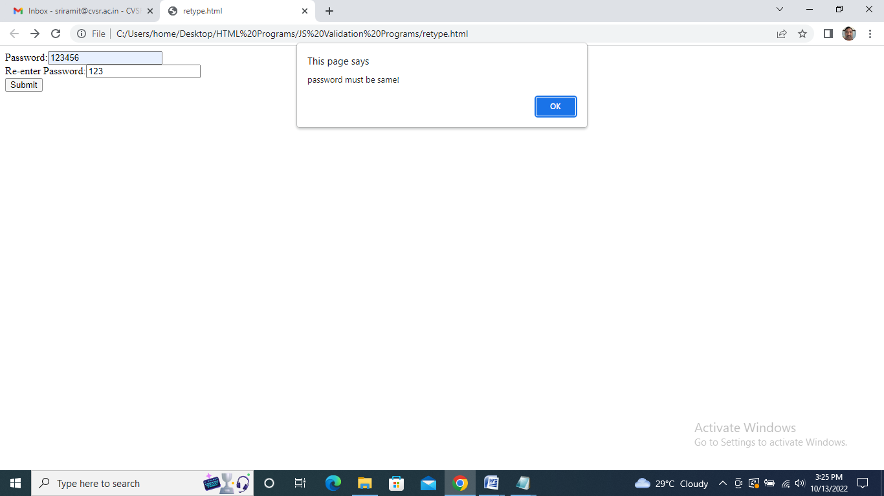

Mobile Number Field Validation Program:

<html>
<head>
<script>
function validate(){
var num=document.myform.num.value;
if (isNaN(num)){
document.getElementById("numloc").innerHTML="Enter Numeric value only";
return false;
}
else
{
return true;
}
}
</script>
</head>
<body>
<form name="myform" onsubmit="return validate()" >
Number: <input type="text" name="num">
<span id="numloc"></span><br/>
<input type="submit" value="submit">
</form>
</body>
</html>

Output:

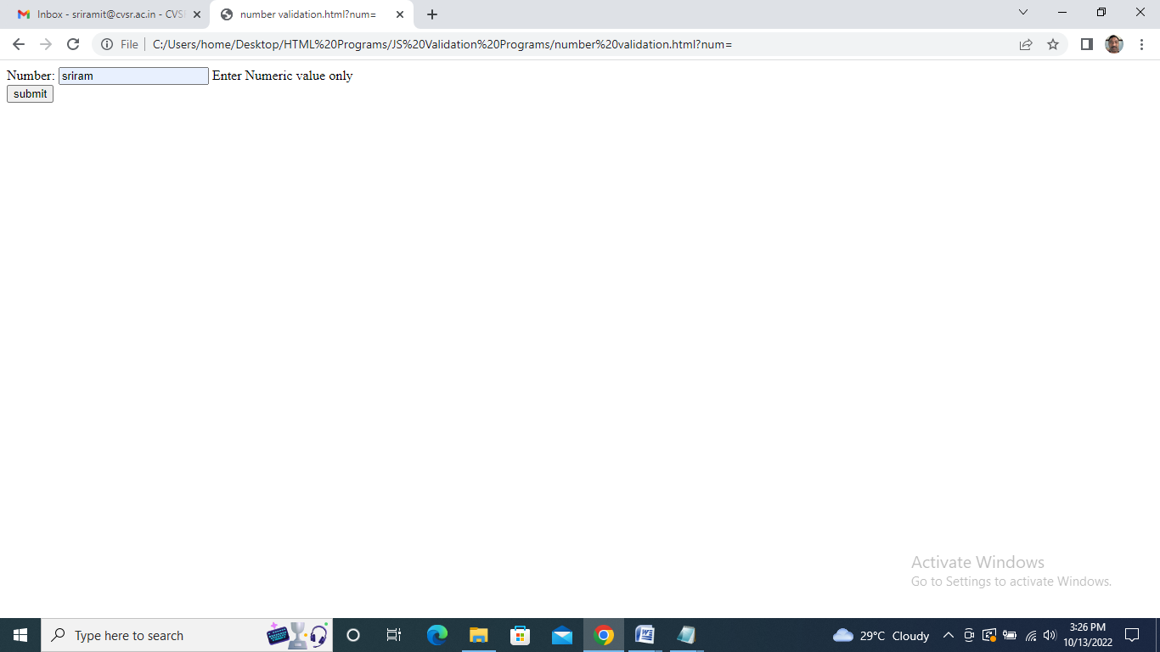

Email-Id Field Validation Program:

<html>
<head>
<script>
function validateemail()
{
var x=document.myform.email.value;
var atposition=x.indexOf("@");
var dotposition=x.lastIndexOf(".");
if (atposition<1 || dotposition<atposition+2 || dotposition+2>=x.length){
alert("Please enter a valid e-mail address \n atpostion:"+atposition+"\n dotposition:"+dotposition);
return false;
}
}
</script>
</head>
<body>
<form name="myform" method="post" action="#" onsubmit="return validateemail();">
Email: <input type="text" name="email"><br/>
<input type="submit" value="register">
</form>
</body>
</html>

Output:

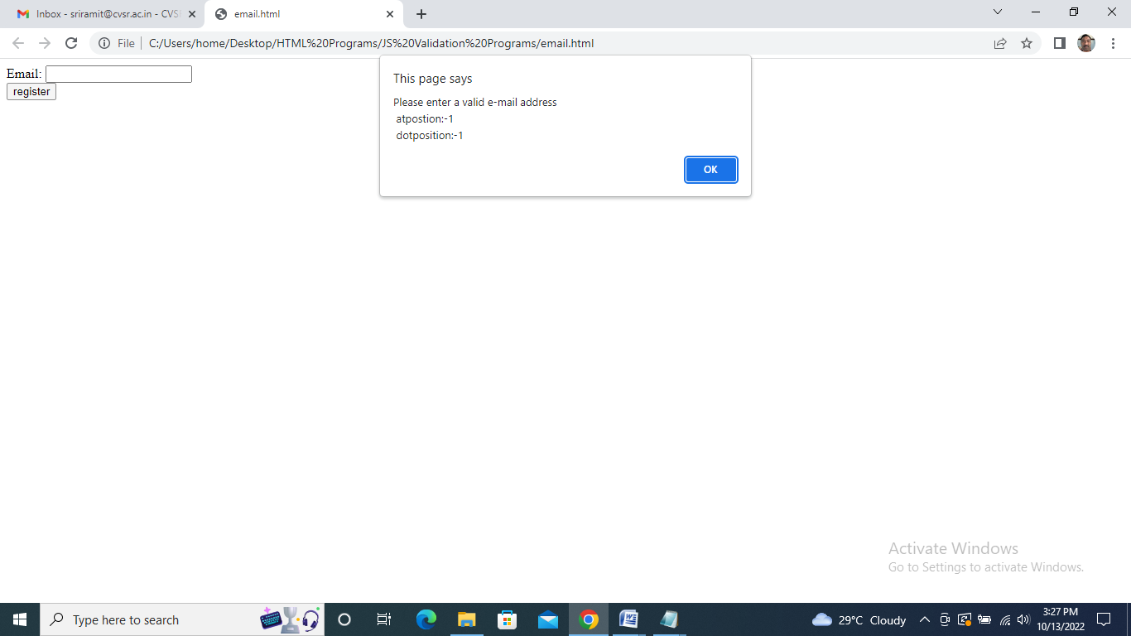

Week 5-6
Introduction to Open Source database tools - MySql / Mongo DB/ No SQL.
Perform Data Definition Language (DDL) and Data Manipulation Language (DML) commands using open source tools.
Implement Database connectivity using JDBC and perform the following:
i) Table creation ii) Data Manipulation.

1. Data Definition Language (DDL)
DDL changes the structure of the table like creating a table, deleting a table, altering a table, etc.
All the command of DDL are auto-committed that means it permanently save all the changes in the database.
Here are some commands that come under DDL:

CREATE
ALTER
DROP
TRUNCATE
a. CREATE It is used to create a new table in the database.

Syntax:
Play Videox

CREATE TABLE TABLE_NAME (COLUMN_NAME DATATYPES[,....]);
Example:

CREATE TABLE EMPLOYEE(Name VARCHAR2(20), Email VARCHAR2(100), DOB DATE);
b. DROP: It is used to delete both the structure and record stored in the table.

Syntax

DROP TABLE table_name;
Example

DROP TABLE EMPLOYEE;
c. ALTER: It is used to alter the structure of the database. This change could be either to modify the characteristics of an existing attribute or probably to add a new attribute.

Syntax:

To add a new column in the table

ALTER TABLE table_name ADD column_name COLUMN-definition;
To modify existing column in the table:

ALTER TABLE table_name MODIFY(column_definitions....);
EXAMPLE

ALTER TABLE STU_DETAILS ADD(ADDRESS VARCHAR2(20));
ALTER TABLE STU_DETAILS MODIFY (NAME VARCHAR2(20));
d. TRUNCATE: It is used to delete all the rows from the table and free the space containing the table.

Syntax:

TRUNCATE TABLE table_name;
Example:

TRUNCATE TABLE EMPLOYEE;

2. Data Manipulation Language
DML commands are used to modify the database. It is responsible for all form of changes in the database.
The command of DML is not auto-committed that means it can't permanently save all the changes in the database. They can be rollback.
Here are some commands that come under DML:

INSERT
UPDATE
DELETE
a. INSERT: The INSERT statement is a SQL query. It is used to insert data into the row of a table.

Syntax:

INSERT INTO TABLE_NAME
(col1, col2, col3,.... col N)
VALUES (value1, value2, value3, .... valueN);
Or

INSERT INTO TABLE_NAME
VALUES (value1, value2, value3, .... valueN);
For example:

INSERT INTO javatpoint (Author, Subject) VALUES ("Sonoo", "DBMS");
b. UPDATE: This command is used to update or modify the value of a column in the table.

Syntax:

UPDATE table_name SET [column_name1= value1,...column_nameN = valueN] [WHERE CONDITION]
For example:

UPDATE students
SET User_Name = 'Sonoo'
WHERE Student_Id = '3'
c. DELETE: It is used to remove one or more row from a table.

Syntax:

DELETE FROM table_name [WHERE condition];
For example:

DELETE FROM javatpoint
WHERE Author="Sonoo";

Implement Database connectivity using JDBC and perform the following:
i) Table creation ii) Data Manipulation.

//JDBConn.java
import java.sql.*;
import java.io.*;
public class JDBConn
{
public static void main(String args[])
{
try
{
Class.forName("com.mysql.jdbc.Driver");
Connection con=DriverManager.getConnection("jdbc:odbc:dsn1","system","123456");
System.out.println("connected");
Statement stmt=con.createStatement();
String st="create table thanvika(rnoint,namevarchar(10),marks int)";
stmt.executeUpdate(st);
System.out.println("table created");
}
catch(Exception e)
{
System.out.println(e);
}}}

//JDBConnectInsert.java
import java.sql.*;
import java.io.*;
public class JDBConnectInsertt
{
public static void main(String[] args)
{
try
{
Class.forName("sun.jdbc.odbc.JdbcOdbcDriver");
Connection con=DriverManager.getConnection("jdbc:odbc:dsn1","system","123456");
System.out.println("connected");
Statement stmt=con.createStatement();
String str="create table madhu1234(rno int,name varchar(10),marks int)";
stmt.executeUpdate(str);
String st1="insert into madhu1234(rno,name,marks) values(36,'madhu',456)";
stmt.executeUpdate(st1);
String st2="insert into madhu1234(rno,name,marks) values(46,'nuuu',356)";
stmt.executeUpdate(st2);
System.out.println("1 row inserted");
}
catch(Exception e)
{
System.out.println(e);
}}}

//JDBConnectAccess.java
import java.sql.*;
import java.io.*;
public class JDBConnectAccess
{
public static void main(String[] args)
{
try
{
Class.forName("sun.jdbc.odbc.JdbcOdbcDriver");
Connection con=DriverManager.getConnection("jdbc:odbc:dsn1","system","cvsrit");
System.out.println("connected");
Statement stmt=con.createStatement();
ResultSet rs=stmt.executeQuery("select * from madhu123");
while(rs.next())
{
int no=rs.getInt(1);
String name=rs.getString(2);
int marks=rs.getInt(3);
System.out.println("number"+no);
System.out.println("name"+name);
System.out.println("marks"+marks);
} }
catch(Exception e)
{
System.out.println(e);
}} }

Output:

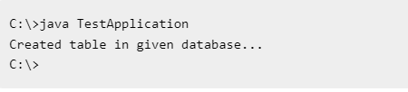

Week 7
Apache Tomcat Installation Procedure.
Write a program to display the HELLO WORLD message using Java servlet.

How to Install Tomcat 7
There are certain steps we must follow for configuring Apache Tomcat 7.
Step 1
Download and Install Tomcat
- Go to http://tomcat.apache.org/download-70.cgi then go to the Binary Distribution/Core/ and download the "zip" package (for example "apache-tomcat-7.0.40.zip", about 8MB).
- Now unzip the downloaded file into a directory of our choice. Don't unzip onto the dekstop (since its path is hard to locate). I suggest using "e:\myserver". Tomcat will be unzipped into the directory "e:\myserver\tomcat-7.0.40".
Step 2
Check the installed directory to ensure it contains the following sub-directories:
- bin folder
- logs folder
- webapps folder
- work folder
- temp folder
- conf folder
- lib folder
Step 3
Now, we need to create an Environment Variable JAVA_HOME.
We need to create an environment variable called "JAVA_HOME" and set it to our JDK installed directory.
- To create the JAVA_HOME environment variable in Windows XP/Vista/7 we need to push the "Start" button then select "Control Panel" / "System" / "Advanced system settings". Then switch to the "Advanced" tab and select "Environment Variables" / "System Variables" then select "New" (or "Edit" for modification). In "Variable Name", enter "JAVA_HOME". In "Variable Value", enter your JDK installed directory (e.g., "c:\Program Files\Java\jdk1.7.0_{xx}").
- For ensuring that it is set correctly, we need to start a command shell (to refresh the environment) and issue:
set JAVA_HOME
JAVA_HOME=c:\Program Files\Java\jdk1.7.0_{xx} <== Check that this is OUR JDK installed directory
- Sometimes we need to set JRE_HOME also. So for creating JRE_HOME we need to use the same procedure. Push the "Start" button then select "Control Panel" / "System" / "Advanced system settings". Then switch to the "Advanced" tab and select "Environment Variables" / "System Variables" then select "New" (or "Edit" for modification). In "Variable Name", enter "JRE_HOME". In "Variable Value", enter your JRE installed directory (e.g., "C:\Program Files\Java\jre7\").

Step 4
Configure Tomcat Server
The configuration files of the Apache Tomcat Server are located in the "conf" sub-directory of our Tomcat installed directory, for example "E:\myserver\tomcat7.0.40\conf". There are 4 configuration XML files:
- context.xml file
- tomcat-users.xml file
- server.xml file
- web.xml file
Before proceeding, make a BACKUP of the configuration files.
Step 4(a) "conf\web.xml"; Enabling a Directory Listing
Open the configuration file "web.xml". We shall enable the directory listing by changing "listings" from "false" to "true" for the "default" servlet.
<param-value>true</param-value> like:
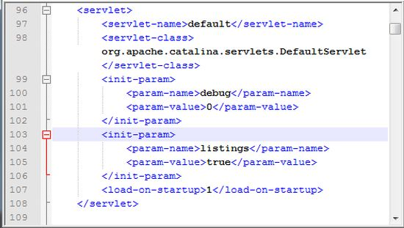
Step 4(b) "conf\server.xml file"; set the TCP Port Number
Open the file "server.xml" in a text editor.
The default port number of Tomcat is 8080. Now we need to change the TCP port number for Tomcat, since the same port number can be used by other servers like SQL Server. We may choose any number between 1024 and 65535. We shall choose 9999 in this article.
Locate the following lines, and change port="8080" to port="9999". Like:
<Connector port="9999" protocol="HTTP/1.1" Like
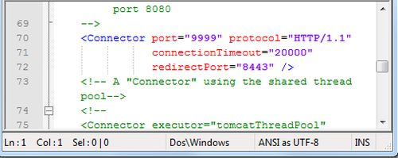
Step 4(c) "conf\context.xml"; Enabling Automatic Reload
In that we set reloadable="true" to the <Context> element to enable automatic reload after code changes.
Add reloadable="true" as in the following:
<Context reloadable="true">
......
</Context> Like
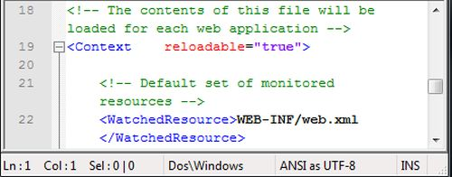
Step 4(d) (Optional) "conf\tomcat-users.xml"
It is used to manage Tomcat by adding the highlighted lines, inside the <tomcat-users> elements.

In that we can add a password and username as an optional step.
Step 5
Now, start the tomcat server
Executable programs and scripts are kept in the "bin" sub-directory of the Tomcat installed directory, e.g., "E:\myserver\tomcat7.0.40\bin".
Step 5(a) Start Server
Launch a command shell. Set the current directory to "<TOMCAT_HOME>\bin" like E:\myserver\tomcat7.0.40\bin, and run "startup.bat" as follows:
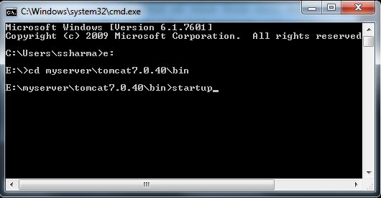
After that a new Tomcat console window appears. Read the messages on the console. Look out for the Tomcat's port number (double check that Tomcat is running on port 9999).......
We saw a figure like:
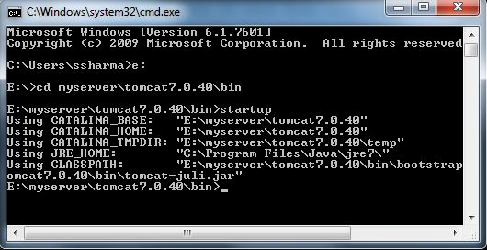
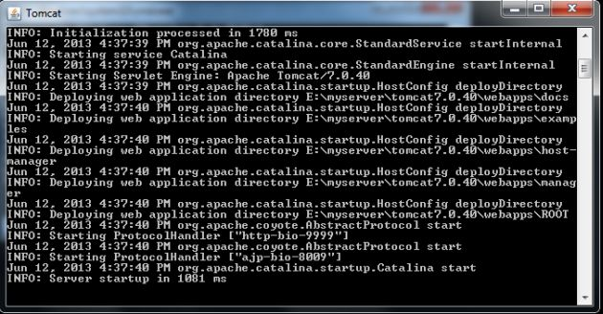
Step 5(b) Access the Server
Open a browser then enter the URL "http://localhost:9999" to access the Tomcat server's welcome page.
If we get this type of page then it means we are done.
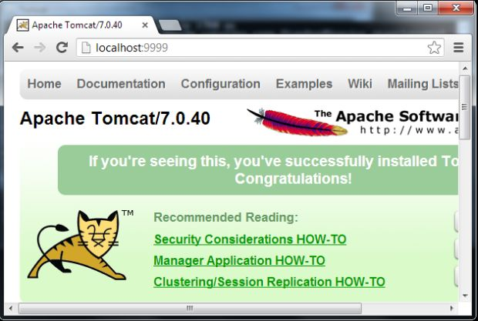
Now try the URL http://localhost:9999/examples to view JSP and servlet examples.
Step 5(c) How to Shutdown Server
We can stop the server using one of the following:
- Press ctrl-c on the Tomcat console; or
- Run "<TOMCAT_HOME>\bin\shutdown.bat" script:
// Change the current directory to Tomcat's "bin"
> e: // Change the current drive
e:\> cd E:\myserver\tomcat7.0.40\bin // Change Directory to YOUR Tomcat's "bin" directory
// Shutdown the server
E:\myserver\tomcat7.0.40\bin> shutdown

Hello World Program:

HelloWorld.java:
import java.io.*;
import javax.servlet.http.*;
import javax.servlet.*;
public class HelloWorld extends HttpServlet{
public void doGet(HttpServletRequest req,HttpServletResponse res)throws ServletException,IOException {
res.setContentType("text/html");
PrintWriter pw=res.getWriter();
pw.println("<html><body>");
pw.println("<h1>Welcome to servlet</h1>");
pw.println("</body></html>");
pw.close();
}
}

Web.xml:

<web-app>
<servlet>
<servlet-name>HelloWorld</servlet-name>
<servlet-class>HelloWorld</servlet-class>
</servlet>
<servlet-mapping>
<servlet-name>HelloWorld</servlet-name>
<url-pattern>/abc</url-pattern>
</servlet-mapping>
</web-app>

Output:

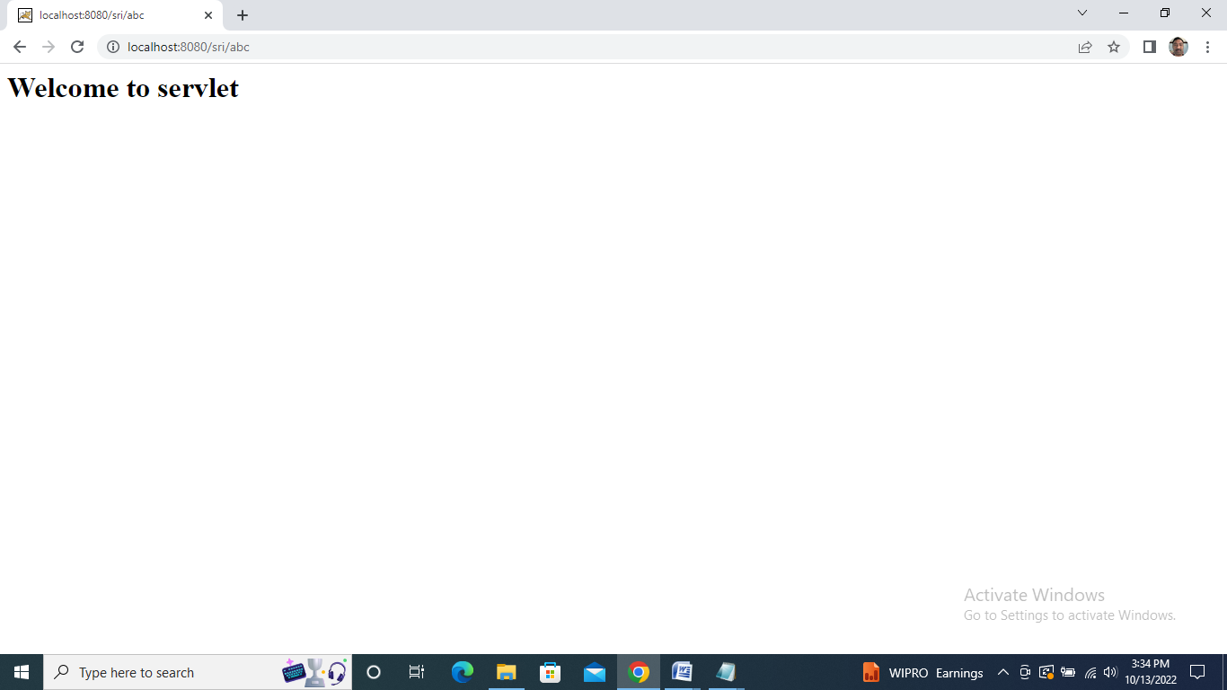

Week 8-9
Develop a Java Servlet application to implement and demonstrate get() and post() methods (Using HTTPServlet Class)
Write a Java Servlet program to implement a dynamic HTML using servlet (Username and password should be accepted using HTML and displayed using Servlet)
Write a JAVA Servlet to track HttpSession by accepting user name and password using HTML and display the profile page on successful login.

get() Method Program:

ExampleHttpServlet.java:
import java.io.*;
import javax.servlet.*;
import javax.servlet.http.*;
// Creating Http Servlet by Extending HttpServlet class
public class ExampleHttpServlet extends HttpServlet
{
private String mymsg;
public void init() throws ServletException
{
mymsg = "Http Servlet Demo";
}
public void doGet(HttpServletRequest request,
HttpServletResponse response) throws ServletException,
IOException
{
// Setting up the content type of web page
response.setContentType("text/html");
// Writing the message on the web page
PrintWriter out = response.getWriter();
out.println("<h1>" + mymsg + "</h1>");
out.println("<p>" + "Hello Friends!" + "</p>");
}
public void destroy()
{
// Leaving empty. Use this if you want to perform
//something at the end of Servlet life cycle.
}
}

Web.xml:
<web-app>
<display-name>BeginnersBookServlet</display-name>
<welcome-file-list>
<welcome-file>index.html</welcome-file>
<welcome-file>index.htm</welcome-file>
<welcome-file>index.jsp</welcome-file>
<welcome-file>default.html</welcome-file>
<welcome-file>default.htm</welcome-file>
<welcome-file>default.jsp</welcome-file>
</welcome-file-list>
<servlet>
<servlet-name>MyHttpServlet</servlet-name>
<servlet-class>ExampleHttpServlet</servlet-class>
</servlet>
<servlet-mapping>
<servlet-name>MyHttpServlet</servlet-name>
<url-pattern>/welcome</url-pattern>
</servlet-mapping>
</web-app>

index.html:
<!DOCTYPE html>
<html>
<head>
<meta charset="UTF-8">
<title>Http Servlet Demo</title>
</head>
<body>
<a href="welcome">Click to call Servlet</a>
</body>
</html>

Output:

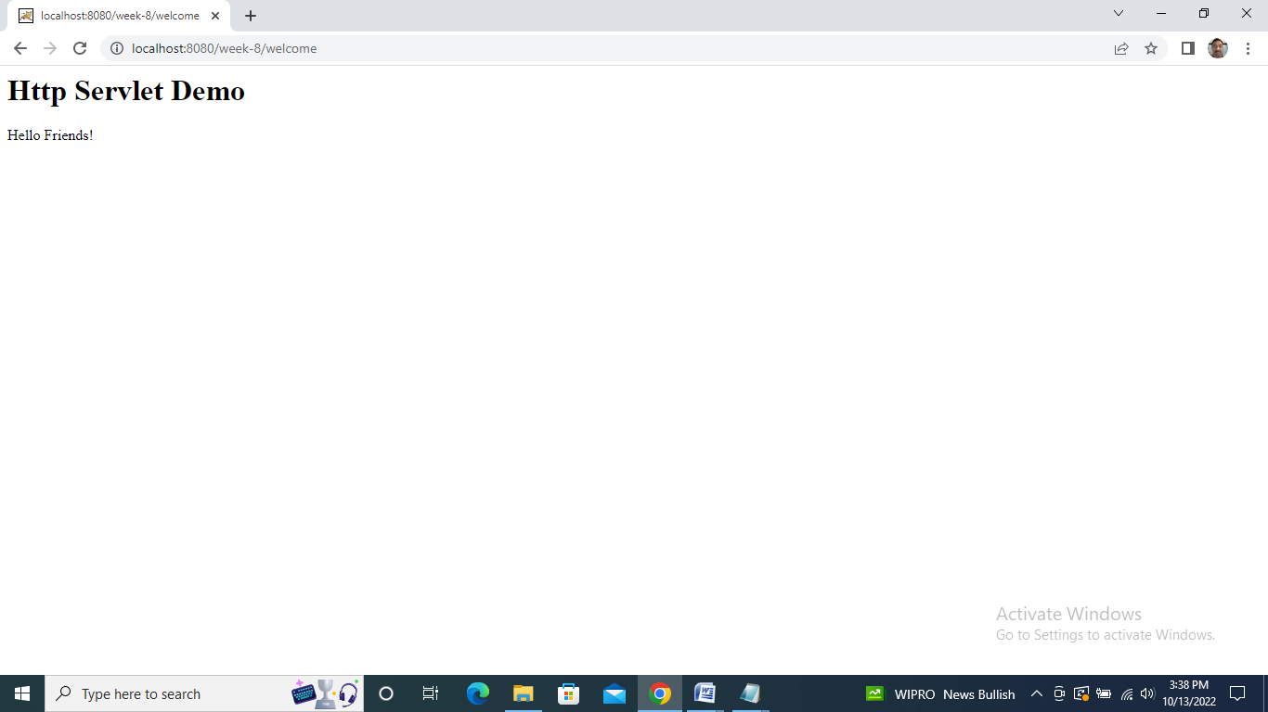

HttpSession by accepting user name and password using HTML and display the profile page Program:

LoginServlet.java:
import java.io.IOException;
import java.io.PrintWriter;

import javax.servlet.ServletException;
import javax.servlet.http.HttpServlet;
import javax.servlet.http.HttpServletRequest;
import javax.servlet.http.HttpServletResponse;
import javax.servlet.http.HttpSession;
public class LoginServlet extends HttpServlet {
protected void doPost(HttpServletRequest request, HttpServletResponse response)
throws ServletException, IOException {
response.setContentType("text/html");
PrintWriter out=response.getWriter();
request.getRequestDispatcher("link.html").include(request, response);

String name=request.getParameter("name");
String password=request.getParameter("password");

if(password.equals("admin123")){
out.print("Welcome, "+name);
HttpSession session=request.getSession();
session.setAttribute("name",name);
}
else{
out.print("Sorry, username or password error!");
request.getRequestDispatcher("login.html").include(request, response);
}
out.close();
}
}

LogoutServlet.java:

import java.io.IOException;
import java.io.PrintWriter;

import javax.servlet.ServletException;
import javax.servlet.http.HttpServlet;
import javax.servlet.http.HttpServletRequest;
import javax.servlet.http.HttpServletResponse;
import javax.servlet.http.HttpSession;
public class LogoutServlet extends HttpServlet {
protected void doGet(HttpServletRequest request, HttpServletResponse response)
throws ServletException, IOException {
response.setContentType("text/html");
PrintWriter out=response.getWriter();

request.getRequestDispatcher("link.html").include(request, response);

HttpSession session=request.getSession();
session.invalidate();

out.print("You are successfully logged out!");

out.close();
}
}

ProfileServlet.java:

import java.io.IOException;
import java.io.PrintWriter;
import javax.servlet.ServletException;
import javax.servlet.http.HttpServlet;
import javax.servlet.http.HttpServletRequest;
import javax.servlet.http.HttpServletResponse;
import javax.servlet.http.HttpSession;
public class ProfileServlet extends HttpServlet {
protected void doGet(HttpServletRequest request, HttpServletResponse response)
throws ServletException, IOException {
response.setContentType("text/html");
PrintWriter out=response.getWriter();
request.getRequestDispatcher("link.html").include(request, response);

HttpSession session=request.getSession(false);
if(session!=null){
String name=(String)session.getAttribute("name");

out.print("Hello, "+name+" Welcome to Profile");
}
else{
out.print("Please login first");
request.getRequestDispatcher("login.html").include(request, response);
}
out.close();
}
}
Web.xml:
<?xml version="1.0" encoding="UTF-8"?>
<web-app xmlns:xsi="http://www.w3.org/2001/XMLSchema-instance"
xmlns="http://java.sun.com/xml/ns/javaee" xsi:schemaLocation="http://java.sun.com/xml/ns/javaee
http://java.sun.com/xml/ns/javaee/web-app_2_5.xsd" id="WebApp_ID" version="2.5">

<servlet>
<description></description>
<display-name>LoginServlet</display-name>
<servlet-name>LoginServlet</servlet-name>
<servlet-class>LoginServlet</servlet-class>
</servlet>
<servlet-mapping>
<servlet-name>LoginServlet</servlet-name>
<url-pattern>/LoginServlet</url-pattern>
</servlet-mapping>
<servlet>
<description></description>
<display-name>ProfileServlet</display-name>
<servlet-name>ProfileServlet</servlet-name>
<servlet-class>ProfileServlet</servlet-class>
</servlet>
<servlet-mapping>
<servlet-name>ProfileServlet</servlet-name>
<url-pattern>/ProfileServlet</url-pattern>
</servlet-mapping>
<servlet>
<description></description>
<display-name>LogoutServlet</display-name>
<servlet-name>LogoutServlet</servlet-name>
<servlet-class>LogoutServlet</servlet-class>
</servlet>
<servlet-mapping>
<servlet-name>LogoutServlet</servlet-name>
<url-pattern>/LogoutServlet</url-pattern>
</servlet-mapping>
</web-app>

index.html:
<!DOCTYPE html>
<html>
<head>
<meta charset="ISO-8859-1">
<title>Servlet Login Example</title>
</head>
<body>

<h1>Login App using HttpSession</h1>
<a href="login.html">Login</a>|
<a href="LogoutServlet">Logout</a>|
<a href="ProfileServlet">Profile</a>
</body>
</html>

Link.html:

<a href="login.html">Login</a> |
<a href="LogoutServlet">Logout</a> |
<a href="ProfileServlet">Profile</a>
<hr>

Login.html:

<form action="LoginServlet" method="post">
Name:<input type="text" name="name"><br>
Password:<input type="password" name="password"><br>
<input type="submit" value="login">
</form>

Output:

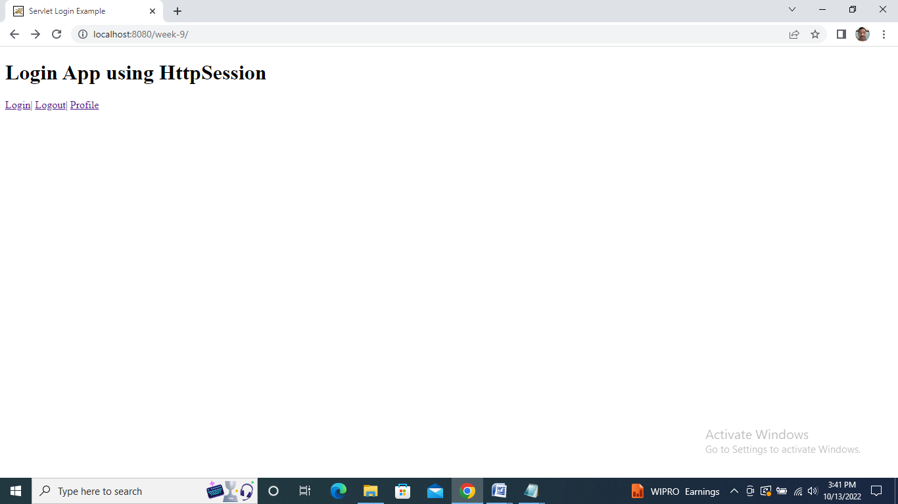

Week 10
Write a Java Servlet application using Cookies to remember user preferences.
Write a Java Servlet to Auto web page refresh (consider a webpage which is displaying Date and time or stock market status. For all such type of pages, you would need to refresh your web page regularly; Java servlet makes this job easy by providing refresh automatically after a given interval.

Cookies Program:

MyServlet1.java:
import java.io.*;
import javax.servlet.*;
import javax.servlet.http.*;
public class MyServlet1 extends HttpServlet
{
public void doGet (HttpServletRequest request, HttpServletResponse response)
{
try
{
response.setContentType ("text/html");
PrintWriter pwriter = response.getWriter ();
String name = request.getParameter ("userName");
String password = request.getParameter ("userPassword");
pwriter.print ("Hello " + name);
pwriter.print ("\nYour Password is: " + password);
//Creating two cookies
Cookie c1 = new Cookie ("userName", name);
Cookie c2 = new Cookie ("userPassword", password);
//Adding the cookies to response header
response.addCookie (c1);
response.addCookie (c2);
pwriter.print ("<br><a href='welcome'>View Details</a>");
pwriter.close ();
}
catch (Exception exp)
{
System.out.println (exp);
}
}
}

MyServlet2.java:
import java.io.*;
import javax.servlet.*;
import javax.servlet.http.*;
public class MyServlet2 extends HttpServlet
{
public void doGet (HttpServletRequest request, HttpServletResponse response)
{
try
{
response.setContentType ("text/html");
PrintWriter pwriter = response.getWriter ();
//Reading cookies
Cookie c[] = request.getCookies ();
//Displaying User name value from cookie
pwriter.print ("Name: " + c[1].getValue ());
//Displaying user password value from cookie
// pwriter.print("Password: "+c[2].getValue());
pwriter.close ();
}
catch (Exception exp)
{
System.out.println (exp);
}
}
}

Web.xml:

<?xml version="1.0" encoding="UTF-8"?>
<web-app version="3.1"
xmlns="http://xmlns.jcp.org/xml/ns/javaee"
xmlns:xsi="http://www.w3.org/2001/XMLSchema-instance" xsi:schemaLocation="http://xmlns.jcp.org/xml/ns/javaee http://xmlns.jcp.org/xml/ns/javaee/web-app_3_1.xsd">
<display-name>LoginExample</display-name>
<welcome-file-list>
<welcome-file>index.html</welcome-file>
</welcome-file-list>
<servlet>
<servlet-name>Servlet1</servlet-name>
<servlet-class>MyServlet1</servlet-class>
</servlet>
<servlet-mapping>
<servlet-name>Servlet1</servlet-name>
<url-pattern>/login</url-pattern>
</servlet-mapping>
<servlet>
<servlet-name>Servlet2</servlet-name>
<servlet-class>MyServlet2</servlet-class>
</servlet>
<servlet-mapping>
<servlet-name>Servlet2</servlet-name>
<url-pattern>/welcome</url-pattern>
</servlet-mapping>
</web-app>

Index.html:

<!DOCTYPE html>
<html>
<head>
<title>Demo</title>
<meta charset="UTF-8">
<meta name="viewport" content="width=device-width, initial-scale=1.0"> </head>
<body>
<form action="login"> User Name:
<input type="text" name="userName" />
<br/> Password:
<input type="password" name="userPassword" />
<br/>
<input type="submit" value="submit" /> </form>
</body>
</html>

Output:

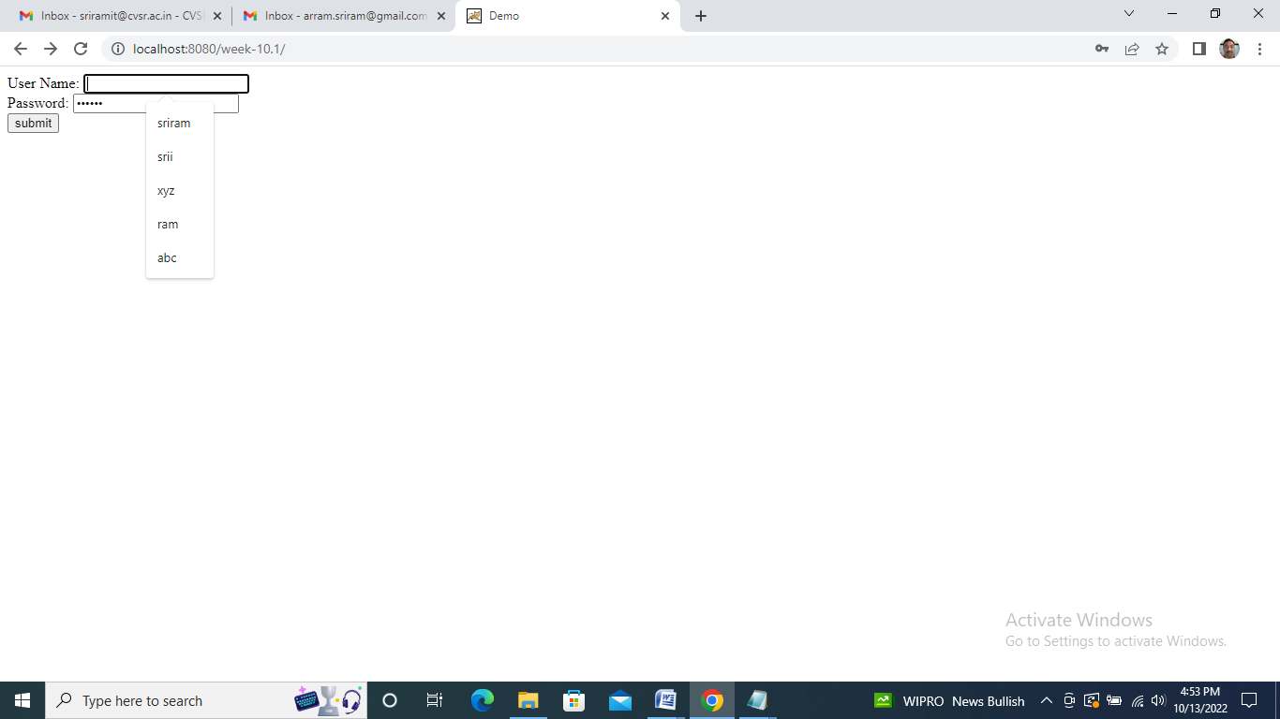

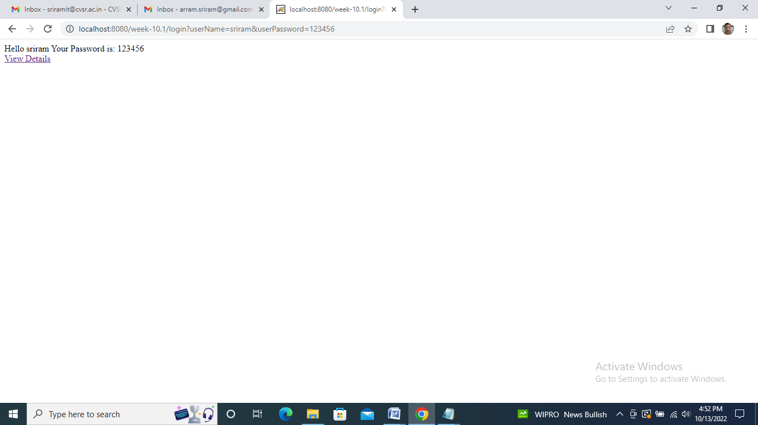

Java Servlet to Auto web page refresh Program:

TestServlet.java:

import java.io.*;
import java.util.Date;
import javax.servlet.*;
import javax.servlet.http.*;
public class TestServlet extends HttpServlet {
protected void processRequest(HttpServletRequest request, HttpServletResponse response)
throws ServletException, IOException {
response.setContentType("text/html;charset=UTF-8");
PrintWriter out = response.getWriter();
try {
response.setContentType("text/html");
response.addHeader("Refresh", "2");
out.println("TestServlet says hi at " + new Date());
} finally {
out.close();
}
}
protected void doGet(HttpServletRequest request, HttpServletResponse response)
throws ServletException, IOException {
processRequest(request, response);
}
protected void doPost(HttpServletRequest request, HttpServletResponse response)
throws ServletException, IOException {
processRequest(request, response);
}
}

Web.xml:

<?xml version="1.0" encoding="UTF-8"?>
<web-app>
<servlet>
<servlet-name>TestServlet</servlet-name>
<servlet-class>TestServlet</servlet-class>
</servlet>
<servlet-mapping>
<servlet-name>TestServlet</servlet-name>
<url-pattern>/home</url-pattern>
</servlet-mapping>
<session-config>
<session-timeout>
30
</session-timeout>
</session-config>
</web-app>

index.html:

<html>
<head>
<title>TODO supply a title</title>
<meta charset="UTF-8">
<meta name="viewport" content="width=device-width, initial-scale=1.0">
</head>
<body>
<p>JAVA Servlet Program to Auto Web Page Refresh</p>
<p>Click on the following link for Auto Web Page Refresh:</p>
<!-- this will redirect to ServletApplication as URL-pattern for ServletApplication was
mentioned as /home -->
<a href="home"><b>More...</b></a> <hr />
</body>
</html>

Output:

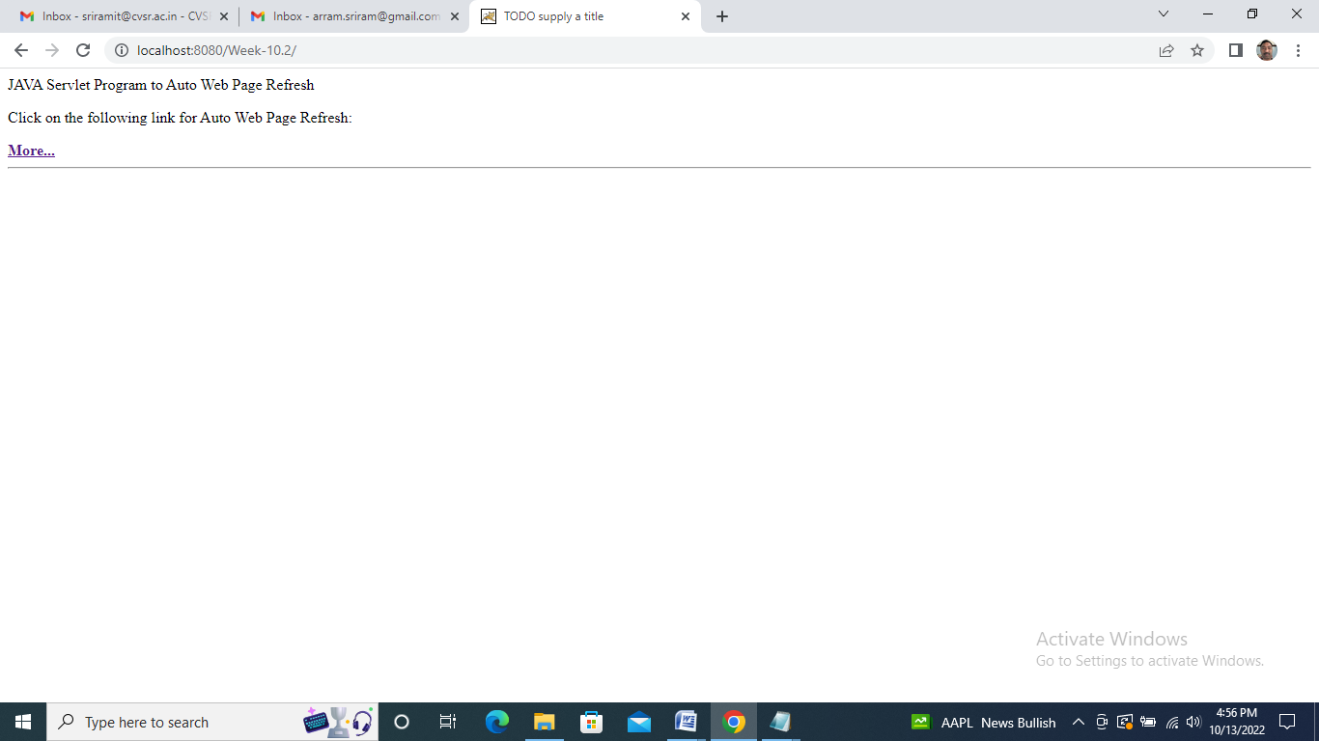

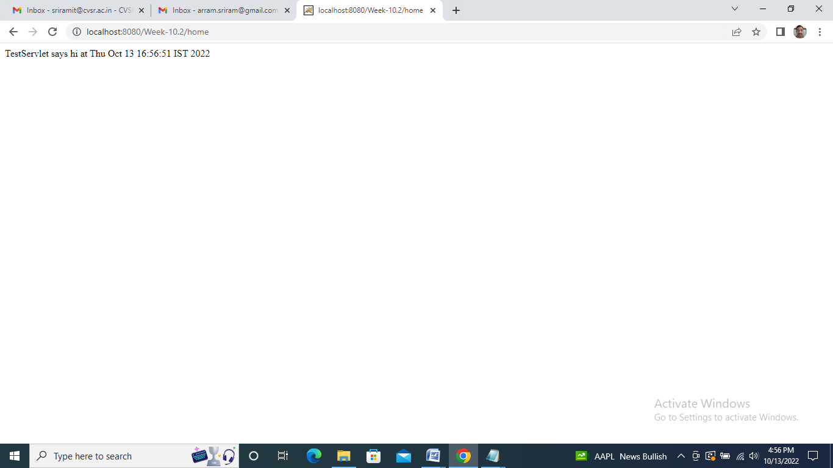

Week 11
Demonstrate the Java servlet-servlet chaining.
Demonstrate the Java servlet and JDBC connection.

GrossServlet.java:

import java.io.IOException;
import java.io.PrintWriter;
import javax.servlet.RequestDispatcher;
import javax.servlet.ServletException;
import javax.servlet.http.HttpServlet;
import javax.servlet.http.HttpServletRequest;
import javax.servlet.http.HttpServletResponse;
public class GrossServlet extends HttpServlet {
public void doGet(HttpServletRequest request, HttpServletResponse response)
throws ServletException, IOException {
response.setContentType("text/html;charset=UTF-8");
PrintWriter out = response.getWriter();
float basic = Float.parseFloat(request.getParameter("basic"));
float da = basic * 0.8f;
float hra = basic * 0.3f;
float gross = basic + da + hra;
request.setAttribute("gr", gross);
RequestDispatcher rd = request.getRequestDispatcher("/target");
rd.forward(request, response);
}
}

NetServlet.java:

import java.io.IOException;
import java.io.PrintWriter;
import javax.servlet.ServletException;
import javax.servlet.http.HttpServlet;
import javax.servlet.http.HttpServletRequest;
import javax.servlet.http.HttpServletResponse;
public class NetServlet extends HttpServlet {
public void doGet(HttpServletRequest request, HttpServletResponse response ) throws ServletException, IOException
{
response.setContentType("text/html;charset=UTF-8");
PrintWriter out = response.getWriter();
//String grs = (String)request.getAttribute("gr");
//float gross = Float.parseFloat(grs);
float gross = (Float) request.getAttribute("gr");
float deduction = gross * 0.05f;
float net = gross - deduction;
out.println("<html>");
out.println("<body>");
out.println("net salary is" + net);
out.println("</body>");
out.println("</html>");
}
}

Web.xml:

<web-app >
<servlet>
<servlet-name>NetServlet</servlet-name>
<servlet-class>NetServlet</servlet-class>
</servlet>
<servlet-mapping>
<servlet-name>NetServlet</servlet-name>
<url-pattern>/target</url-pattern>
</servlet-mapping>
<servlet>
<servlet-name>GrossServlet</servlet-name>
<servlet-class>GrossServlet</servlet-class>
</servlet>
<servlet-mapping>
<servlet-name>GrossServlet</servlet-name>
<url-pattern>/source</url-pattern>
</servlet-mapping>
<welcome-file-list>
<welcome-file>basic.html</welcome-file>
</welcome-file-list>
</web-app>

Basic.html:

<html>
<body bgcolor =" cyan">
<center>
<h1>SALARY DETAILS</h1>
<form action="./source">
BASIC: <input type="text" name="basic">
<br><br>
<input type="submit" value="submit">
</form>
</center>
</body>
</html>

Output:

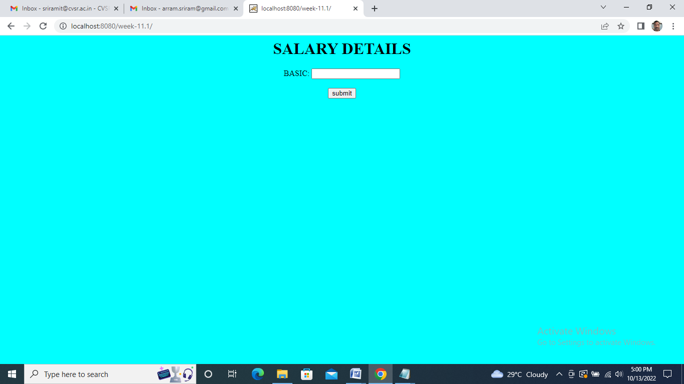

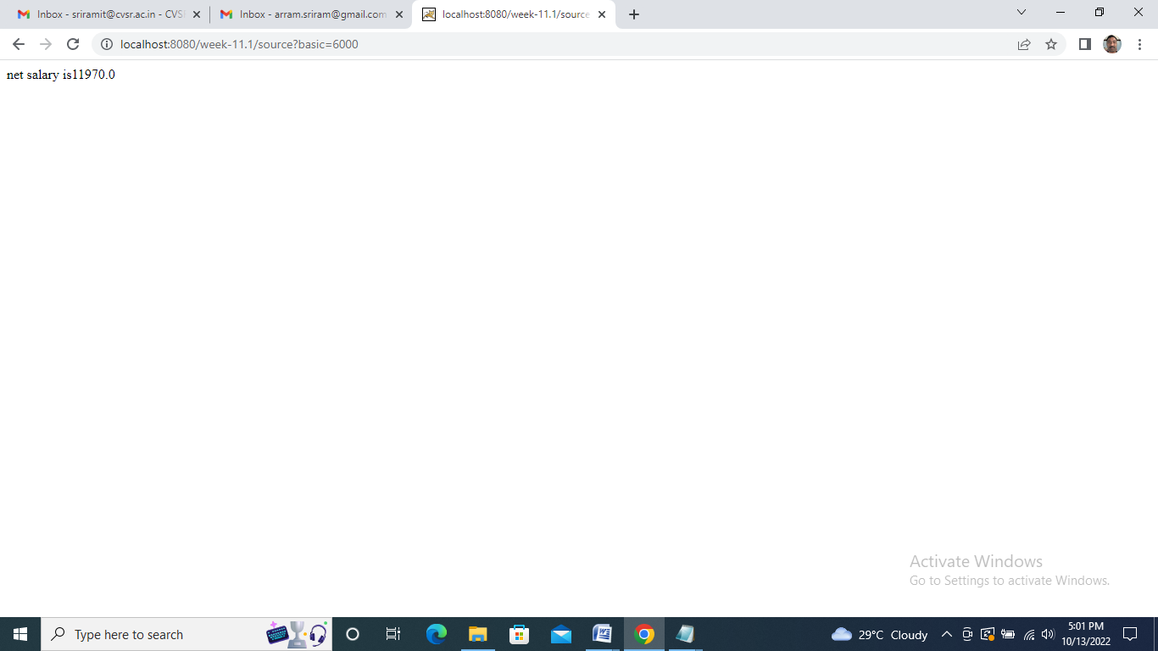

Demonstrate the Java servlet and JDBC connection Program:

Create Table
To create the Employees table in TEST database, use the following steps −

Step 1
Open a Command Prompt and change to the installation directory as follows −
C:\>
C:\>cd Program Files\MySQL\bin
C:\Program Files\MySQL\bin>
Step 2
Login to database as follows
C:\Program Files\MySQL\bin>mysql -u root -p
Enter password: ********
mysql>
Step 3
Create the table Employee in TEST database as follows −
mysql> use TEST;
mysql> create table Employees (
id int not null,
age int not null,
first varchar (255),
last varchar (255)
);
Query OK, 0 rows affected (0.08 sec)
mysql>
Create Data Records
Finally you create few records in Employee table as follows −
mysql> INSERT INTO Employees VALUES (100, 18, 'Zara', 'Ali');
Query OK, 1 row affected (0.05 sec)

mysql> INSERT INTO Employees VALUES (101, 25, 'Mahnaz', 'Fatma');
Query OK, 1 row affected (0.00 sec)

mysql> INSERT INTO Employees VALUES (102, 30, 'Zaid', 'Khan');
Query OK, 1 row affected (0.00 sec)

mysql> INSERT INTO Employees VALUES (103, 28, 'Sumit', 'Mittal');
Query OK, 1 row affected (0.00 sec)

mysql>
Accessing a Database
Here is an example which shows how to access TEST database using Servlet.
// Loading required libraries
import java.io.*;
import java.util.*;
import javax.servlet.*;
import javax.servlet.http.*;
import java.sql.*;

public class DatabaseAccess extends HttpServlet{

public void doGet(HttpServletRequest request, HttpServletResponse response)
throws ServletException, IOException {

// JDBC driver name and database URL
static final String JDBC_DRIVER = "com.mysql.jdbc.Driver";
static final String DB_URL="jdbc:mysql://localhost/TEST";

// Database credentials
static final String USER = "root";
static final String PASS = "password";

// Set response content type
response.setContentType("text/html");
PrintWriter out = response.getWriter();
String title = "Database Result";

String docType =
"<!doctype html public \"-//w3c//dtd html 4.0 " + "transitional//en\">\n";

out.println(docType +
"<html>\n" +
"<head><title>" + title + "</title></head>\n" +
"<body bgcolor = \"#f0f0f0\">\n" +
"<h1 align = \"center\">" + title + "</h1>\n");
try {
// Register JDBC driver
Class.forName("com.mysql.jdbc.Driver");

// Open a connection
Connection conn = DriverManager.getConnection(DB_URL, USER, PASS);

// Execute SQL query
Statement stmt = conn.createStatement();
String sql;
sql = "SELECT id, first, last, age FROM Employees";
ResultSet rs = stmt.executeQuery(sql);

// Extract data from result set
while(rs.next()){
//Retrieve by column name
int id = rs.getInt("id");
int age = rs.getInt("age");
String first = rs.getString("first");
String last = rs.getString("last");

//Display values
out.println("ID: " + id + "<br>");
out.println(", Age: " + age + "<br>");
out.println(", First: " + first + "<br>");
out.println(", Last: " + last + "<br>");
}
out.println("</body></html>");

// Clean-up environment
rs.close();
stmt.close();
conn.close();
} catch(SQLException se) {
//Handle errors for JDBC
se.printStackTrace();
} catch(Exception e) {
//Handle errors for Class.forName
e.printStackTrace();
} finally {
//finally block used to close resources
try {
if(stmt!=null)
stmt.close();
} catch(SQLException se2) {
} // nothing we can do
try {
if(conn!=null)
conn.close();
} catch(SQLException se) {
se.printStackTrace();
} //end finally try
} //end try
}
}
Now let us compile above servlet and create following entries in web.xml
....
<servlet>
<servlet-name>DatabaseAccess</servlet-name>
<servlet-class>DatabaseAccess</servlet-class>
</servlet>

<servlet-mapping>
<servlet-name>DatabaseAccess</servlet-name>
<url-pattern>/DatabaseAccess</url-pattern>
</servlet-mapping>

Output:

Emp id | Age | Name | SrName
100 | 18 | Zara | Ali
101 | 25 | Mahnaz | Fatma
102 | 30 | Zaid | Khan
103 | 28 | Sumit | Mittal

Week 12-13
Introduction to JSP.
Write a program to display the HELLO WORLD message using JSP.
Write a JSP program which uses jsp:include and jsp:forward action to display a Webpage.
Write a Java JSP program which uses <jsp:plugin> tag to run a applet.

HelloWorld.jsp:

<html>
<head><title>Hello World JSP Page.</title></head>
<body>
<font size="10"><%="Hello World!" %></font>
</body>
</html>

Web.xml:

<web-app>

</web-app>

Output:

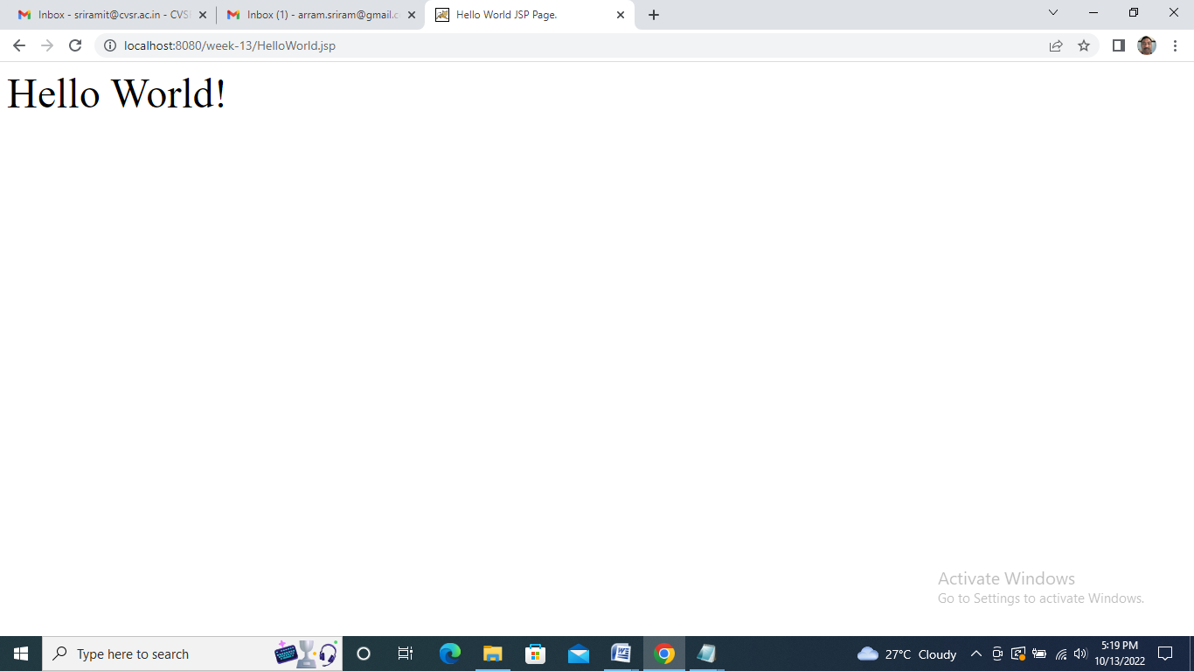

JSP program which uses jsp:include and jsp:forward action to display a Webpage Program:

Header.jsp:

<%@ page import="java.util.Date" %>
<html>
<head>
<title> </title>
</head>
<body>
<h1>
My website. Time:
<% Date d=new Date();%>
<%=d%>
</h1>
</body>
</html>

Index.jsp:

<html>
<head>
<title>Index Page</title>
</head>
<body>
<center>
<jsp:include page="header.jsp"/>
<br />
<h1>
Enter Data
</h1>
<br />
<form method="post" action="val.jsp">
Username:
<input type="text" name="uname"/>
<br/> password:
<input type="password" name="upass"/>
<br/>
<input type="submit" value="login">
</form>
</center>
</body>
</html>

Val.jsp:

<% if(request.getParameter("uname").equals("student") &&
request.getParameter("upass").equals("ait")){%>
<jsp:forward page="welcome.jsp" />
<%}
else{ %>
<jsp:forward page="index.jsp" />
<% } %>

Welcome.jsp:

<!DOCTYPE html>
<html>
<head>
<title>welcome page</title>
</head>
<body bgcolor="pink">
<center>
<jsp:include page="header.jsp"/><br/>
<h1>Welcome Mr./Ms. <%=request.getParameter("uname") %></h1>
</center>
</body>
</html>

Web.xml:

<web-app>

</web-app>

Output:
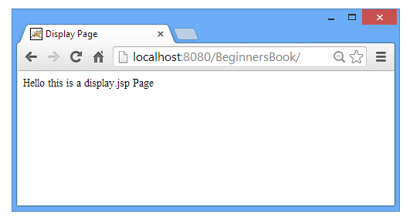

JSP program which uses <jsp:plugin> tag to run a applet Program:

MyApplet:

import java.awt.*;
import java.applet.*;
public class Myapplet extends Applet
{
public void init()
{
setBackground(Color.blue);
}
public void paint(Graphics g)
{
int y=50,x=50;
for(int i=0;i<8;i++)
{
for(int j=0;j<8;j++)
{
if((i+j)%2!=0)
{
g.setColor(Color.black);
}
else
{
g.setColor(Color.white);
}
g.fillRect(x,y,50,50);
x=x+50;
}
y=y+50;
x=50;
}
}
}

Web.xml:

<web-app>

</web-app>

Output:

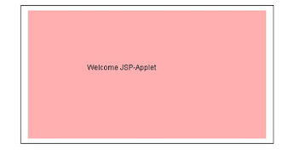

Week 14-15
Write a JSP application to insert data into the STUDENT database and retrieve info based on particular queries (For example, update, delete, and others).
Write a Java JSP program to implement all attribute of page directive tag.

For insert data in MySQL using JSP first we have to create a table in data base.
The INSERT INTO statement is used to insert new data to a MySQL table:
INSERT INTO table_name (column1, column2, column3,...) VALUES (value1, value2, value3,...)
For creating table the SQL query is:
SQL Query:
CREATE TABLE users
(
id int NOT NULL AUTO_INCREMENT,
first_name varchar(50),
last_name varchar(50),
city_name varchar(50),
email varchar(50),
PRIMARY KEY (id)
);
Here we using 2 files for insert data in MySQL:
- index.html:for getting the values from the user
- process.jsp:A JSP file that process the request
index.html:

<!DOCTYPE html>
<html>
<body>
<form method="post" action="process.jsp">
First name:<br>
<input type="text" name="first_name">
<br>
Last name:<br>
<input type="text" name="last_name">
<br>
City name:<br>
<input type="text" name="city_name">
<br>
Email Id:<br>
<input type="email" name="email">
<br><br>
<input type="submit" value="submit">
</form>
</body>
</html>

process.jsp

<%@ page language="java" contentType="text/html; charset=ISO-8859-1"
pageEncoding="ISO-8859-1"%>
<%@page import="java.sql.*,java.util.*"%>
<%
String first_name=request.getParameter("first_name");
String last_name=request.getParameter("last_name");
String city_name=request.getParameter("city_name");
String email=request.getParameter("email");
try
{
Class.forName("com.mysql.jdbc.Driver");
Connection conn = DriverManager.getConnection("jdbc:mysql://localhost:3306/test", "root", "");
Statement st=conn.createStatement();
int i=st.executeUpdate("insert into users(first_name,last_name,city_name,email)values('"+first_name+"','"+last_name+"','"+city_name+"','"+email+"')");
out.println("Data is successfully inserted!");
}
catch(Exception e)
{
System.out.print(e);
e.printStackTrace();
}
%>

Output
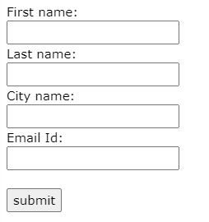

JSP program to implement all attribute of page directive tag

1)import
The import attribute is used to import class,interface or all the members of a package.It is similar to import keyword in java class or interface.

Example of import attribute

Example of import attribute
<html>
<body>
<%@ page import="java.util.Date" %>
Today is: <%= new Date() %>
</body>
</html>

2)contentType
The contentType attribute defines the MIME(Multipurpose Internet Mail Extension) type of the HTTP response.The default value is "text/html;charset=ISO-8859-1".

Example of contentType attribute
<html>
<body>
<%@ page contentType=application/msword %>
Today is: <%= new java.util.Date() %>
</body>
</html>

3)extends
The extends attribute defines the parent class that will be inherited by the generated servlet.It is rarely used.

4)info
This attribute simply sets the information of the JSP page which is retrieved later by using getServletInfo() method of Servlet interface.

Example of info attribute
<html>
<body>
<%@ page info="composed by Sonoo Jaiswal" %>
Today is: <%= new java.util.Date() %>
</body>
</html>
The web container will create a method getServletInfo() in the resulting servlet.For example:

public String getServletInfo() {
return "composed by Sonoo Jaiswal";
}

5)buffer
The buffer attribute sets the buffer size in kilobytes to handle output generated by the JSP page.The default size of the buffer is 8Kb.

Example of buffer attribute
<html>
<body>
<%@ page buffer="16kb" %>
Today is: <%= new java.util.Date() %>
</body>
</html>

6) language
The language attribute specifies the scripting language used in the JSP page. The default value is "java".

7) isELIgnored
We can ignore the Expression Language (EL) in jsp by the isELIgnored attribute. By default its value is false i.e. Expression Language is enabled by default. We see Expression Language later.

<%@ page isELIgnored="true" %>//Now EL will be ignored

8) isThreadSafe
Servlet and JSP both are multithreaded.If you want to control this behaviour of JSP page, you can use isThreadSafe attribute of page directive.The value of isThreadSafe value is true.If you make it false, the web container will serialize the multiple requests, i.e. it will wait until the JSP finishes responding to a request before passing another request to it.If you make the value of isThreadSafe attribute like:
<%@ page isThreadSafe="false" %>
The web container in such a case, will generate the servlet as:
public class SimplePage_jsp extends HttpJspBase
implements SingleThreadModel{
.......
}

9) errorPage
The errorPage attribute is used to define the error page, if exception occurs in the current page, it will be redirected to the error page.

Example of errorPage attribute
//index.jsp
<html>
<body>

<%@ page errorPage="myerrorpage.jsp" %>

<%= 100/0 %>
</body>
</html>

10) isErrorPage
The isErrorPage attribute is used to declare that the current page is the error page.

Example of isErrorPage attribute

//myerrorpage.jsp
<html>
<body>
<%@ page isErrorPage="true" %>
Sorry an exception occured!<br/>
The exception is: <%= exception %>
</body>
</html>

<%@ page language="java" contentType="text/html;" pageEncoding="ISO-8859-1"
isELIgnored="false"%>
<%@page import="java.util.Date" %>

<!DOCTYPE html PUBLIC "-//W3C//DTD HTML 4.01 Transitional//EN" "http://www.w3.org/TR/html4/loose.dtd">
<html>
<head>
<meta http-equiv="Content-Type" content="text/html; charset=ISO-8859-1">
<title>Directive Guru JSP1</title>
</head>
<body>
<a>Date is:</a>
<%= new java.util.Date() %>
</body>
</html>

Output:

